Guidelines for Musculoskeletal Necropsy of Racehorses
February 20, 2024
Preamble
The Horseracing Integrity and Safety Act, passed by Congress in 2020, established the Horseracing Integrity and Safety Authority (HISA). The Authority established a Racetrack Safety Program and an Antidoping Medication and Control Program with the goal of enhancing equine welfare and safety. These Programs established rules approved by the Federal Trade Commission.
Among the rules is the requirement that ‘All Horses that die or are euthanized on Racetrack grounds shall have an autopsy (necropsy) examination performed’ (Rule 2170 Necropsies (a)). Further, Gross necropsy examination findings must be submitted by the Regulatory Veterinarian to the Authority within 72 hours of receiving the necropsy report, and updates submitted to the Authority within 72 hours as the results of ancillary tests and the final report are received. This workflow shall be included in the necropsy standard operating procedures.
This document describes components of necropsy of racehorses that died because of a musculoskeletal injury. The document focuses on documentation of:
- evidence for consideration of rule violations (crop misuse, horseshoe requirements, neurectomy, counterirritants),
- musculoskeletal abnormalities associated with cause of death, and
- pathology findings indicative of pre-existing injury associated with acute complete bone fracture (reflects an opportunity for education and prevention of similar catastrophic fractures in other horses).
Evidence of pre-existing pathology can often be observed on gross necropsy examination and evidenced by:
- periosteal callus in association with the fracture in long or flat bone fractures (pre-existing stress fracture), or
- subchondral stress remodeling in association with articular fractures.
These changes are often bilateral, so examination of the contralateral limb in addition to the affected limb is important, can be insightful and useful for trainer education.
Necropsy findings will be conveyed to the attending veterinarian and trainer of the affected horse in a review by the Racetrack Safety and Welfare (Risk Management) Committee (Rule 2121). The goal is to educate parties involved in the care of the horse so that similar fractures may be prevented in future horses.

Horse documentation and signalment
Horse registered name
Horse HISA number
Horse breed (Thoroughbred, Quarter Horse, Standardbred, Arabian, Appaloosa, Mixed Breed, Pony, Other)
Horse sex (female, intact male, gelding, ridgling)
Horse age
Verify the horse’s identification (microchip, color, markings, tattoo)
Nutritional condition of the horse
State of postmortem decomposition
Document circumstances leading up to death

Radiographs
Request clinical radiographs.
When possible, take orthogonal (dorsopalmar and mediolateral) radiographs of the injured structure and of the contralateral (intact) structure. These are useful for characterizing the fracture configuration but may also be helpful in visualizing pre-existing pathology for education of parties involved in the care of the horse.
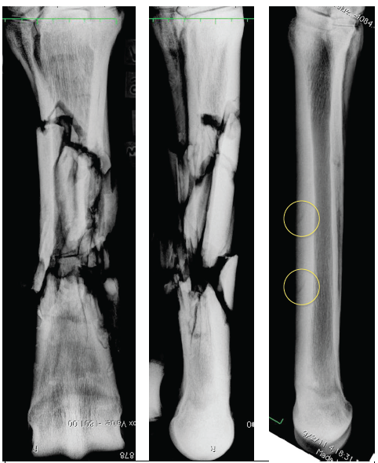 | In this example, the horse incurred a catastrophic mid-diaphyseal third metacarpal bone fracture that was associated with a pre-existing stress fracture located at the distal end of the fracture fragments and mirrored the distal incomplete stress fracture in the contralateral limb. This information is helpful to the trainer and attending veterinarian because knowledge of the pre-existing stress fractures could have prevented the catastrophic fracture.

Hooves and Horseshoes
Photograph all 4 hooves with horseshoes in place, to include:
Dorsal view
Lateral or Medial view
Solar view
Palmar/plantar view
Example views (hooves do not need to be disarticulated from the limbs – photos cropped to illustrate projections relative to the solar surface and orthogonal planes). Include horse ID, hoof, and ruler in images.
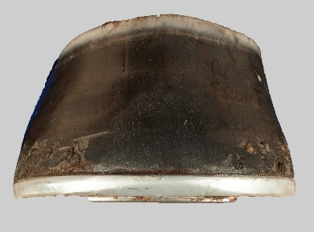 | 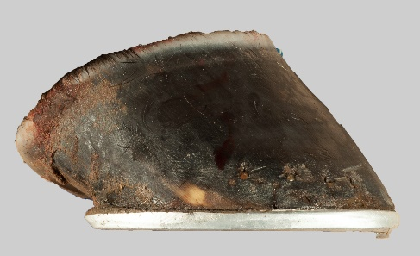 | 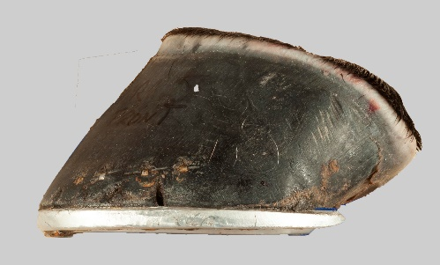
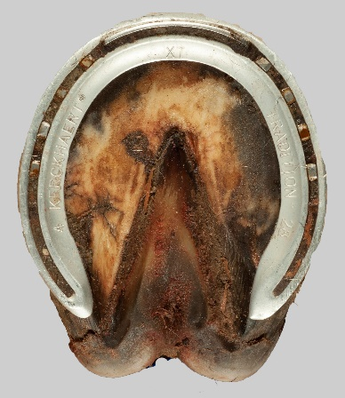 | 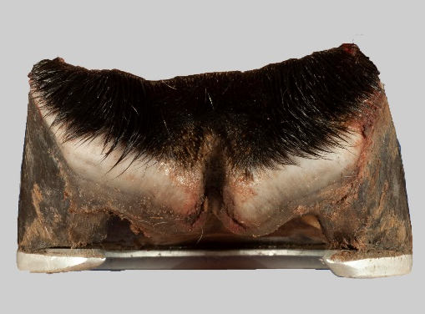 | Note the presence of a traction devices such as a toe grab which is prohibited on forelimb hooves.

Gross Examination of the Skin
Note any welts, lacerations that may be related to use of the crop or horse abuse.
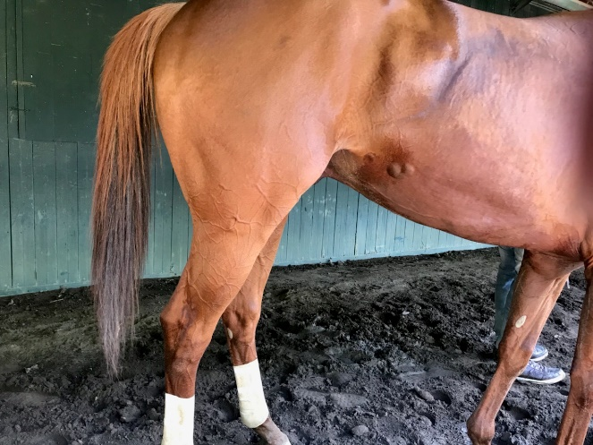 | 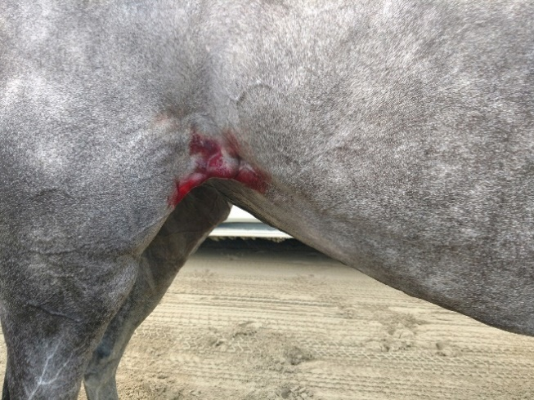

Note any vesiculation or irritation of the skin that may be related to pin firing, freeze firing, or application of counterirritants.
Note any incisions/scars/neuromas that may be related to neurectomy or previous surgeries.

Examination of the Mouth, Nose, and Jaw
Note any abnormalities of the lips, tongue, gums, and teeth that may be related to a lip chain, bit or tongue tie.
Note any abnormalities of the bridge of the nose and under the jaw that may be related to lead chain/shank.

Bone Fracture Configuration and Diagram
Classify fracture components and diagram the configuration of fractures on bone diagrams with designation of fracture components and documentation of any observed pre-existing pathology. Examples illustrated and bone diagrams for use appended to this document. Bone diagram templates can be found at the end of this document and at https://vorl.vetmed.ucdavis.edu/continuing-education.
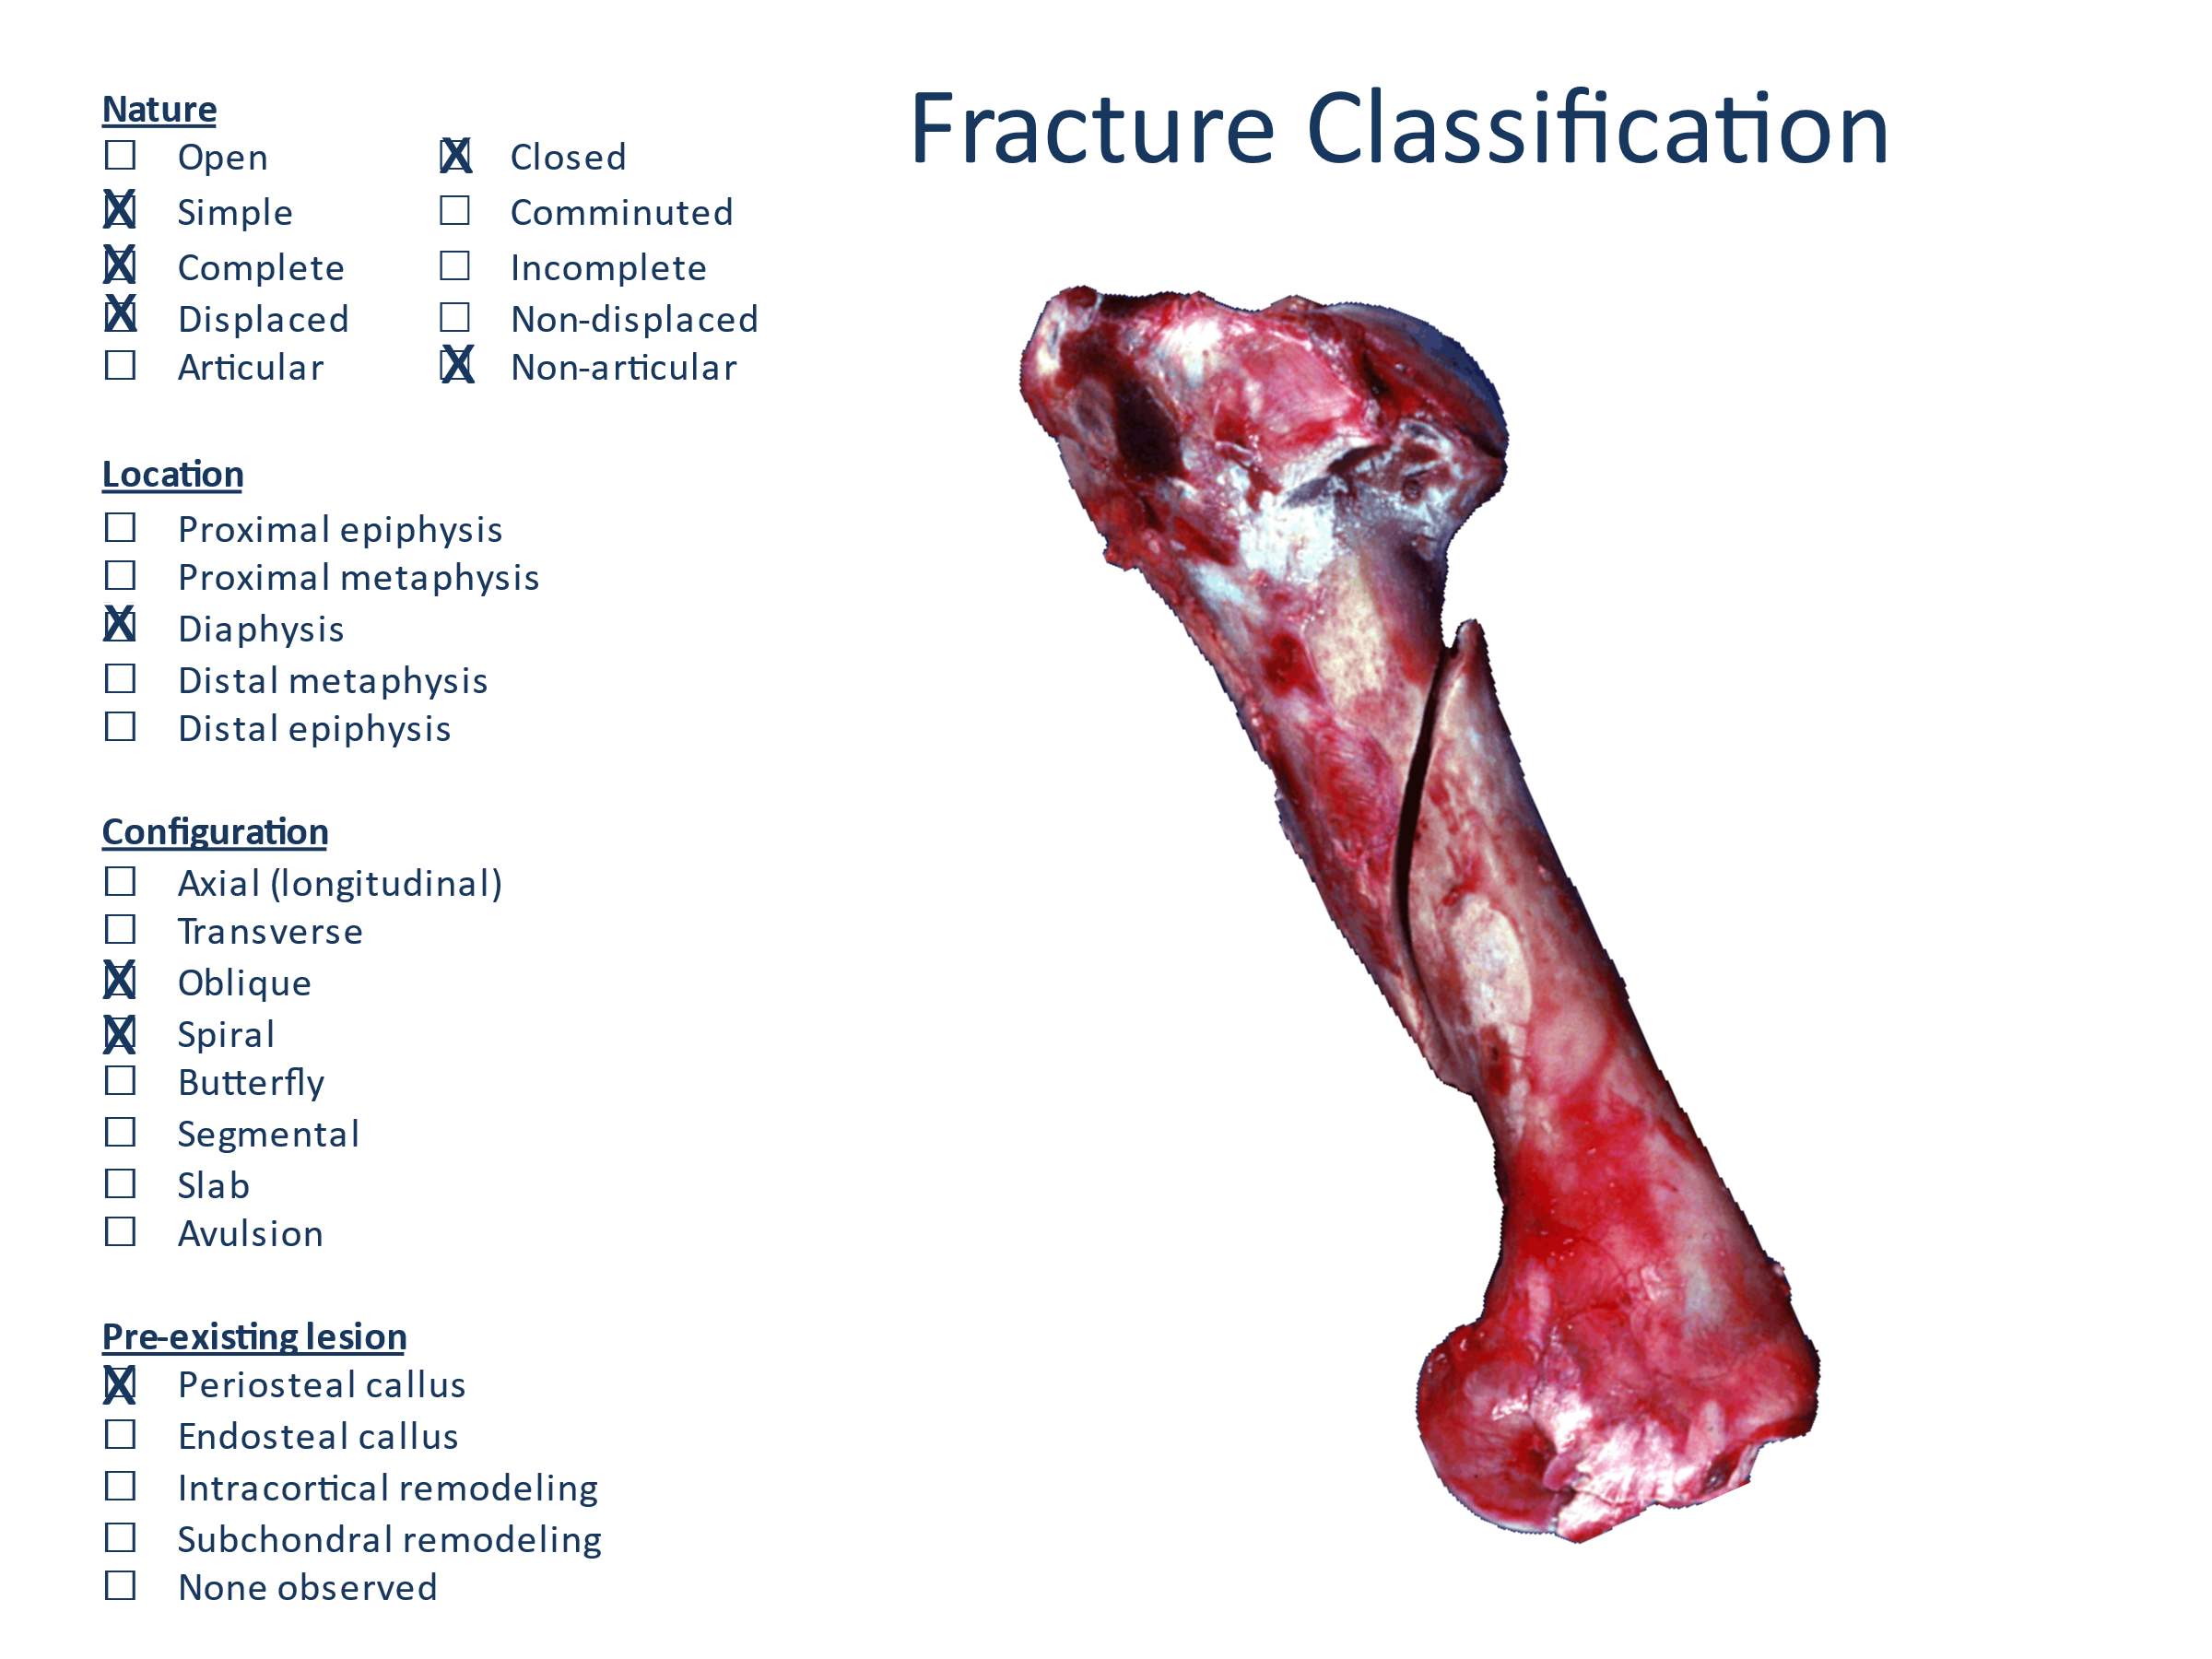
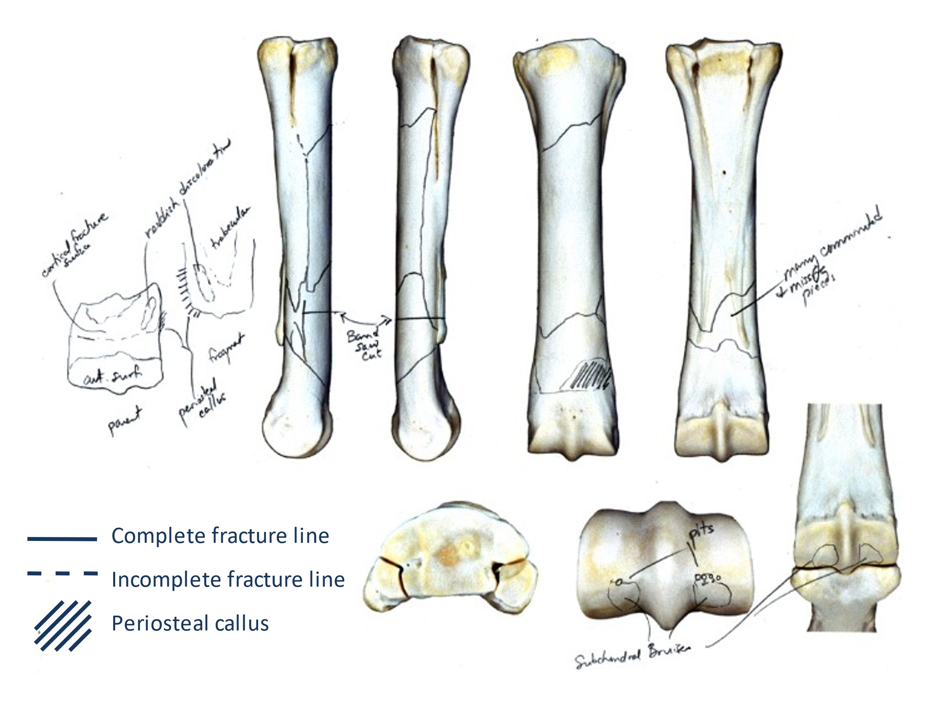
Document Pre-existing Pathology
Most catastrophic fractures are associated with pre-existing pathology that is recognized by the presence of either (or a combination of):
- periosteal callus in association with a fracture surface (± intracortical remodeling)
- subchondral stress remodeling
Periosteal callus  Usually associated with cortical stress fractures of long bones. May be accompanied by intracortical remodeling and endosteal trabecular compaction (sclerosis)  Key features:  1) must be associated with the fracture line  2) acute – red, rough surfaced, woven bone (orange ellipses)  3) chronic – smoother, remodeled lamellar bone (yellow ellipse)  4) mixture of acute and chronic | 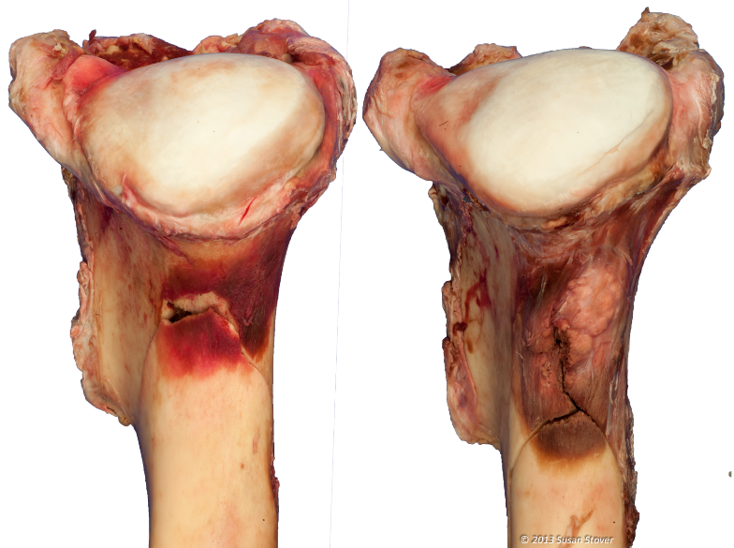
Subchondral stress remodeling  Usually associated with articular fractures (e.g., metacarpal condyle, proximal sesamoid bone, third carpal bone)  Key features:  - Must be associated with the fracture surface  - Reddish focus surrounded by compacted (sclerotic) trabecular bone | 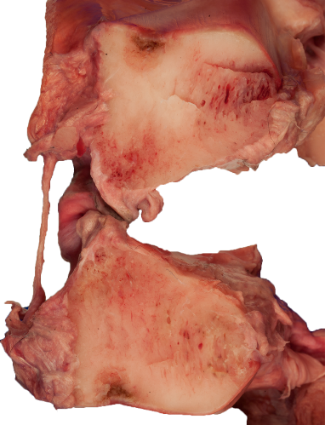
Intracortical Remodeling  May be associated with pre-existing stress fractures.  Key features:  - Must be associated with the fracture surface  - Reddish focus associated with focal osteopenia on an intracortical fracture surface  - Periosteal new bone on the cortical surface  [Fragment from a third metacarpal bone catastrophic fracture associated with a pre-existing stress fracture at this location] | 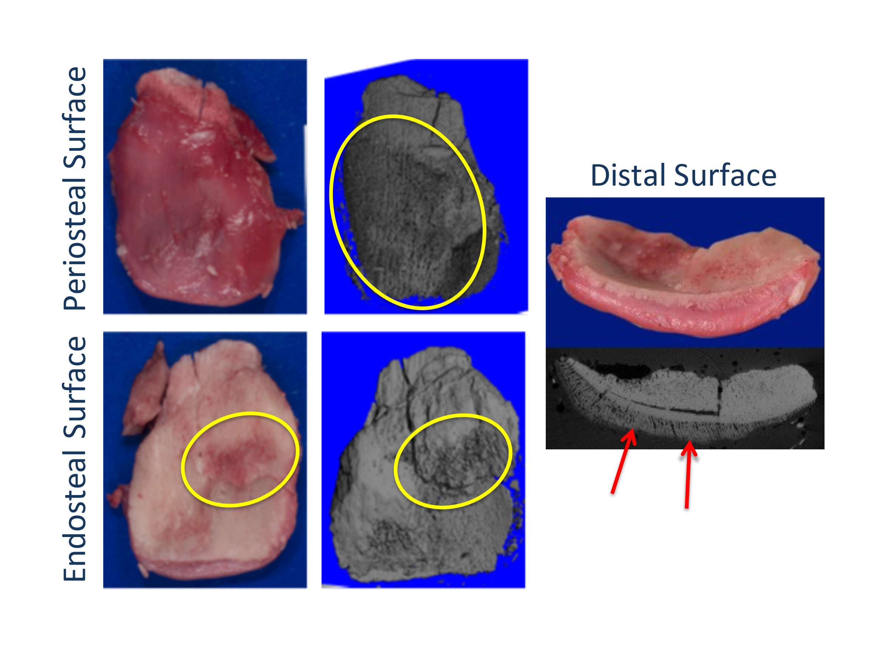

A video illustrating postmortem examination of a catastrophic fetlock injury can be found at the link below.
Postmortem Examination of a Racehorse Forelimb Fetlock Breakdown

Typical Bone Fractures with Associated Pre-existing Pathology
Scapula – Complete fracture usually has a transverse component at the level of the end of the spine. Periosteal callus on the spine at this location is indicative of pre-existing stress fracture
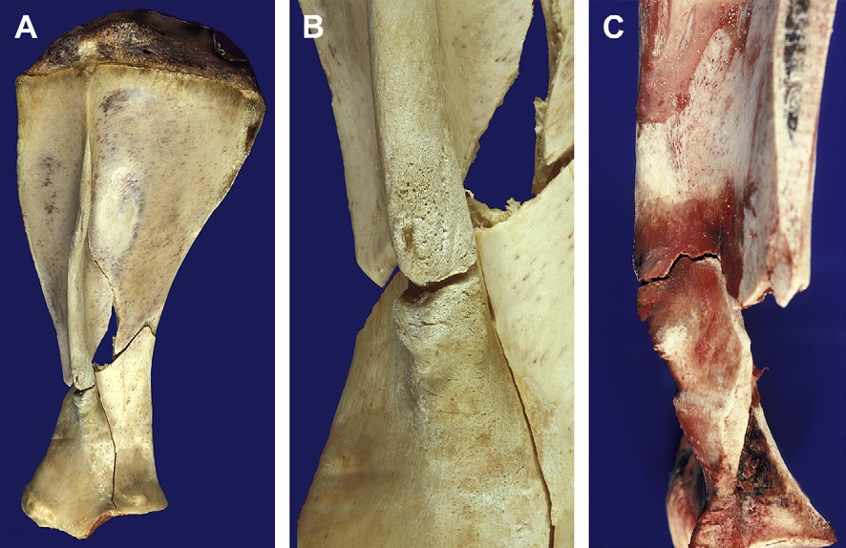
Humerus - Complete fracture usually is an oblique fracture coursing through the neck of the humerus. Periosteal callus is usually located at the neck of the humerus (but can occur elsewhere along the fracture (medial aspect of diaphysis or craniodistal)), and is indicative of pre-existing stress fracture.
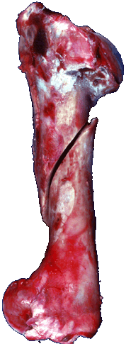 |  | 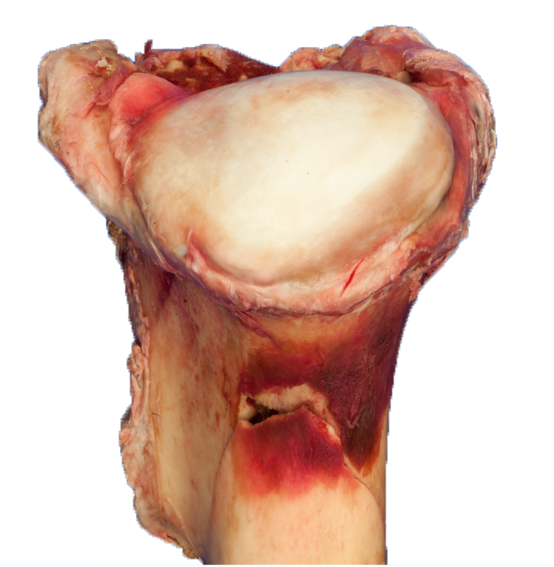
Radius/Ulna – Unusual for these bones to have a catastrophic fracture. At this time, no evidence of a pre-existing stress fracture. However, this fracture has been found in horses that fell during a race and had a vertebral fracture. Recommend checking the vertebral spine in horses with a radius/ulna fracture.
Carpus – Multiple carpal bones are affected in catastrophic fractures. However, the pre-existing lesion that predisposes to fracture is frequently observed in the third carpal bone, and evidenced by subchondral bone remodeling.
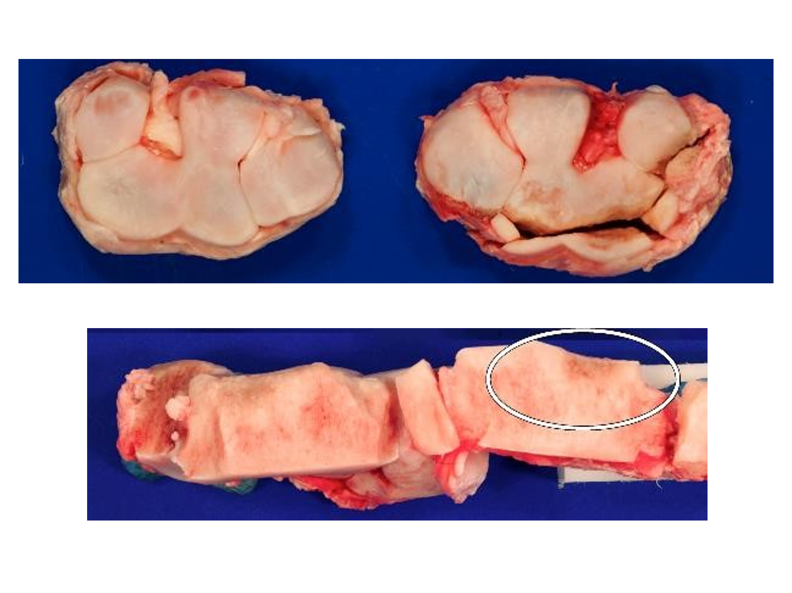
Metacarpus – Fractures of the diaphysis and distal metaphyseal region are usually associated with a pre-existing intracortical incomplete stress fracture. Periosteal callus is usually present on a mid-diaphyseal or distal metaphyseal fragment. Intracortical remodeling may also be observed on the fracture surface of an affected fracture fragment.
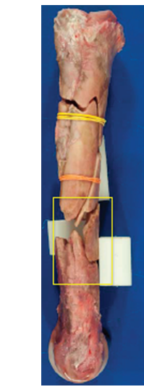 | 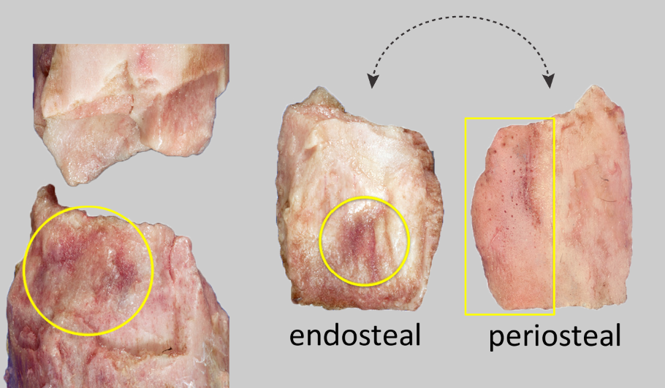
Metacarpal Condyle – may be associated with a palmar osteochondral lesion (POD) or parasagittal groove fissure (PGR)
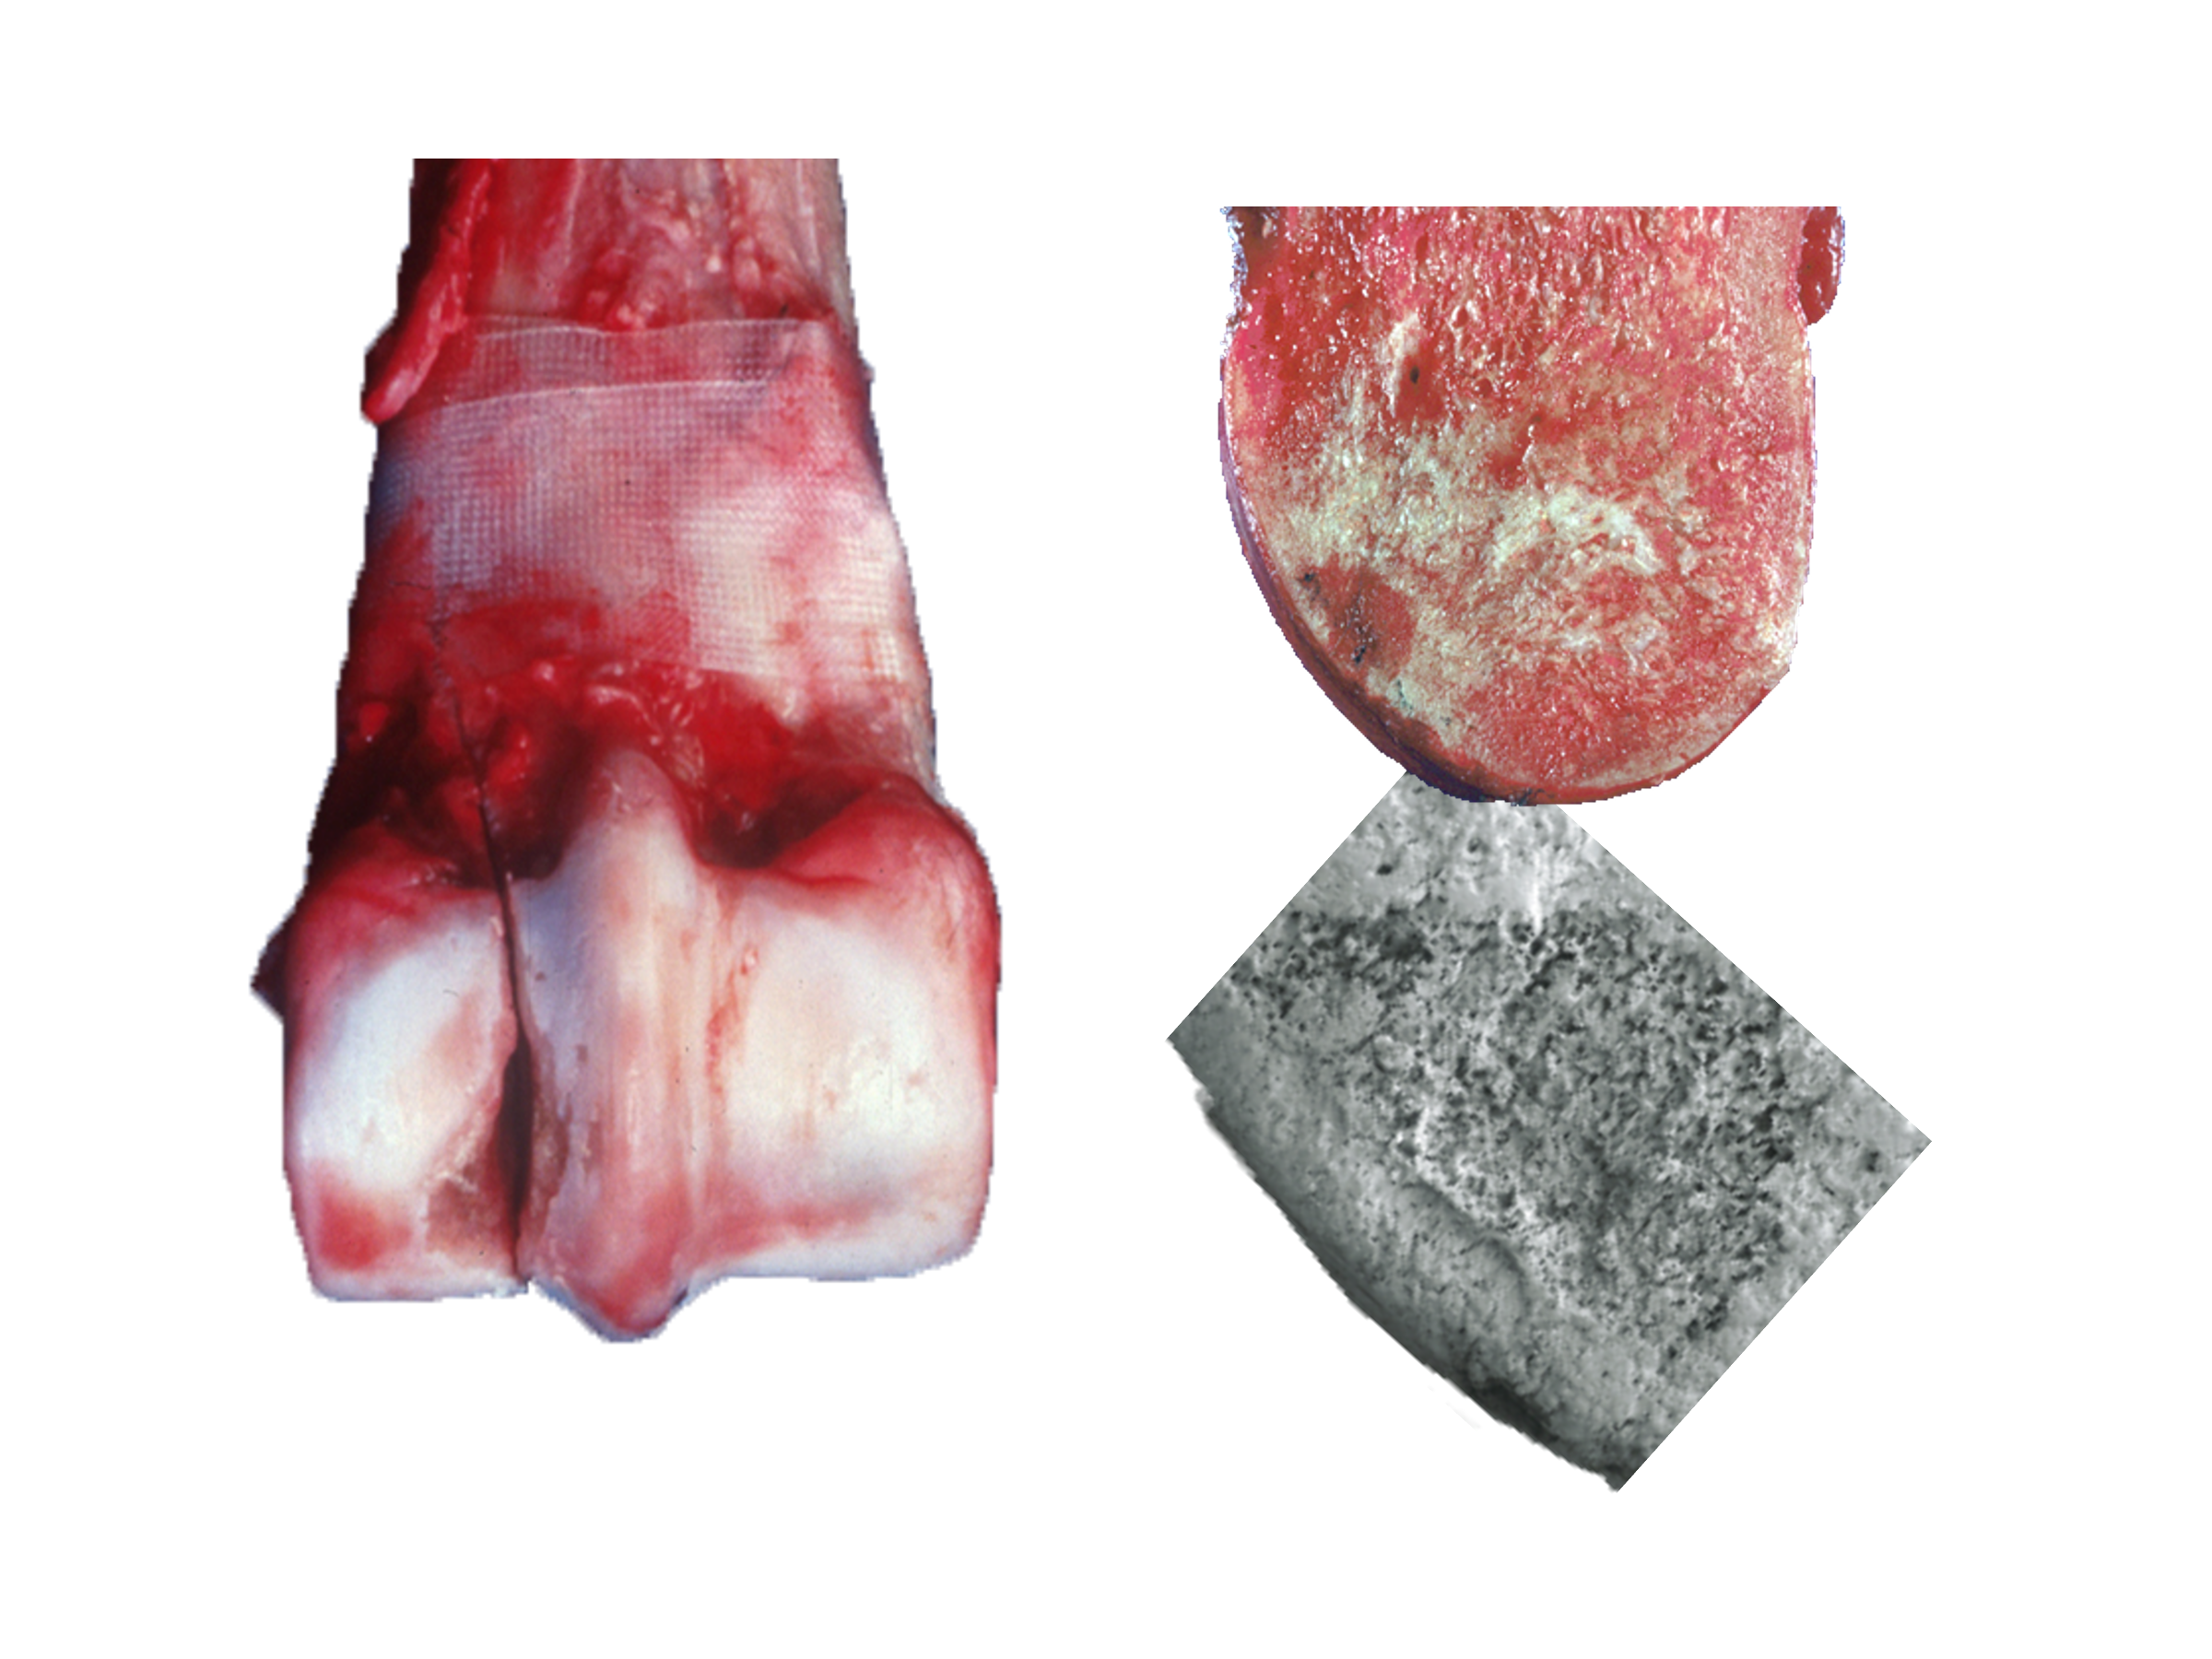
Proximal Sesamoid Bone Fracture(s) – Most commonly observed pre-existing lesion is subchondral bone remodeling on the abaxial half of a transverse fracture through the medial proximal sesamoid bone. Lesions can occur in other places or other bones in complex fetlock breakdowns (simultaneous fractures of metacarpal condyle, proximal sesamoid bones, and the proximal phalanx).
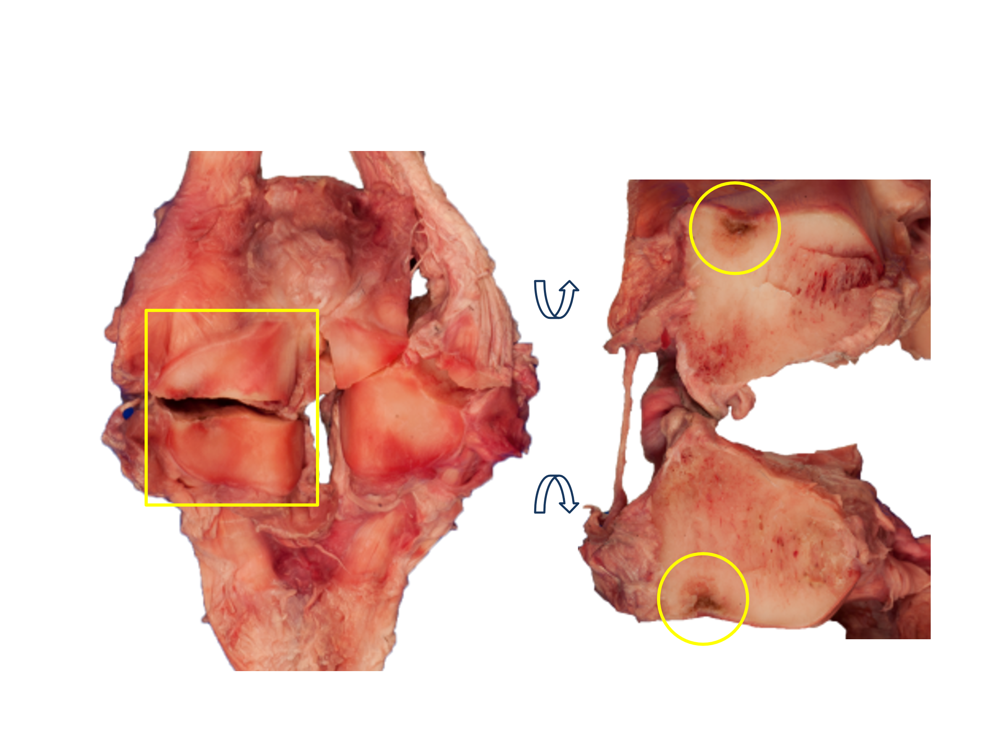
Proximal Phalanx – Some fractures may be associated with subchondral bone remodeling in the proximal articular surface, or incomplete stress fractures of the proximodorsal cortex.
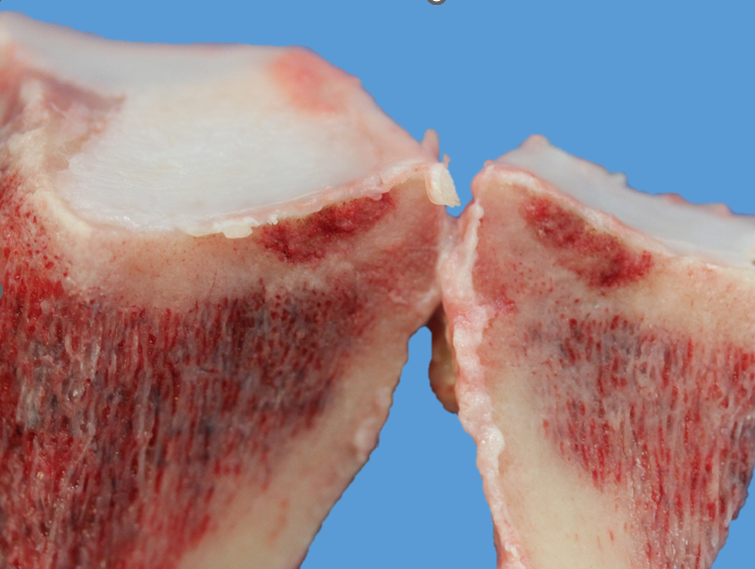
Courtesy of Dr. Monica Samol
Pelvis – Pelvic fractures are usually associated with pre-existing periosteal callus. Periosteal callus can be present in a variety of locations (ilium and pubis). The most common location is on the caudal border of the ilium directly over the sacroiliac joint.
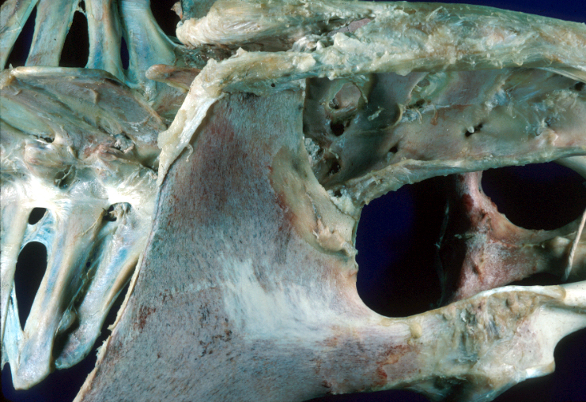 |  |  | 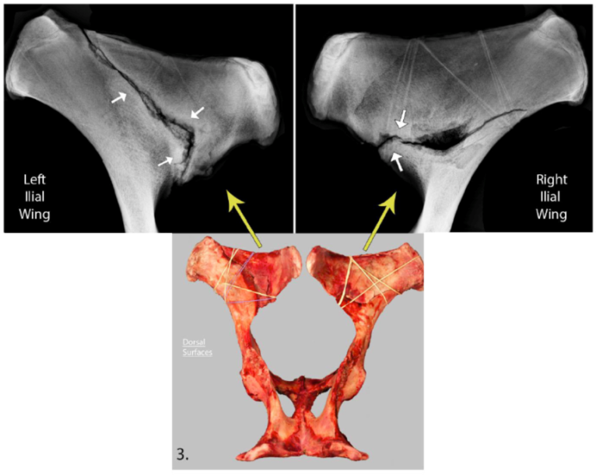

Tibia – Tibial fractures are usually related to a pre-existing stress fracture in one of 2 locations: 1) proximolateral under the head of the fibula or 2) caudal cortex of the tibial diaphysis.
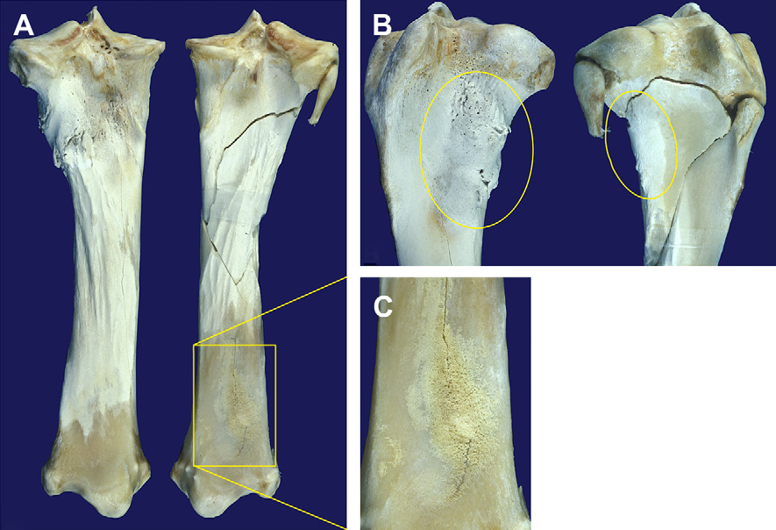

Vertebral – If the cause of death is likely musculoskeletal but fractures are not found in the limbs, consider vertebral column lesions. Sagittal section of the vertebral column can help to identify lesions. A common site for vertebral fractures is in the most caudal lumbar vertebrae. Periosteal callus is indicative of pre-existing stress fracture.
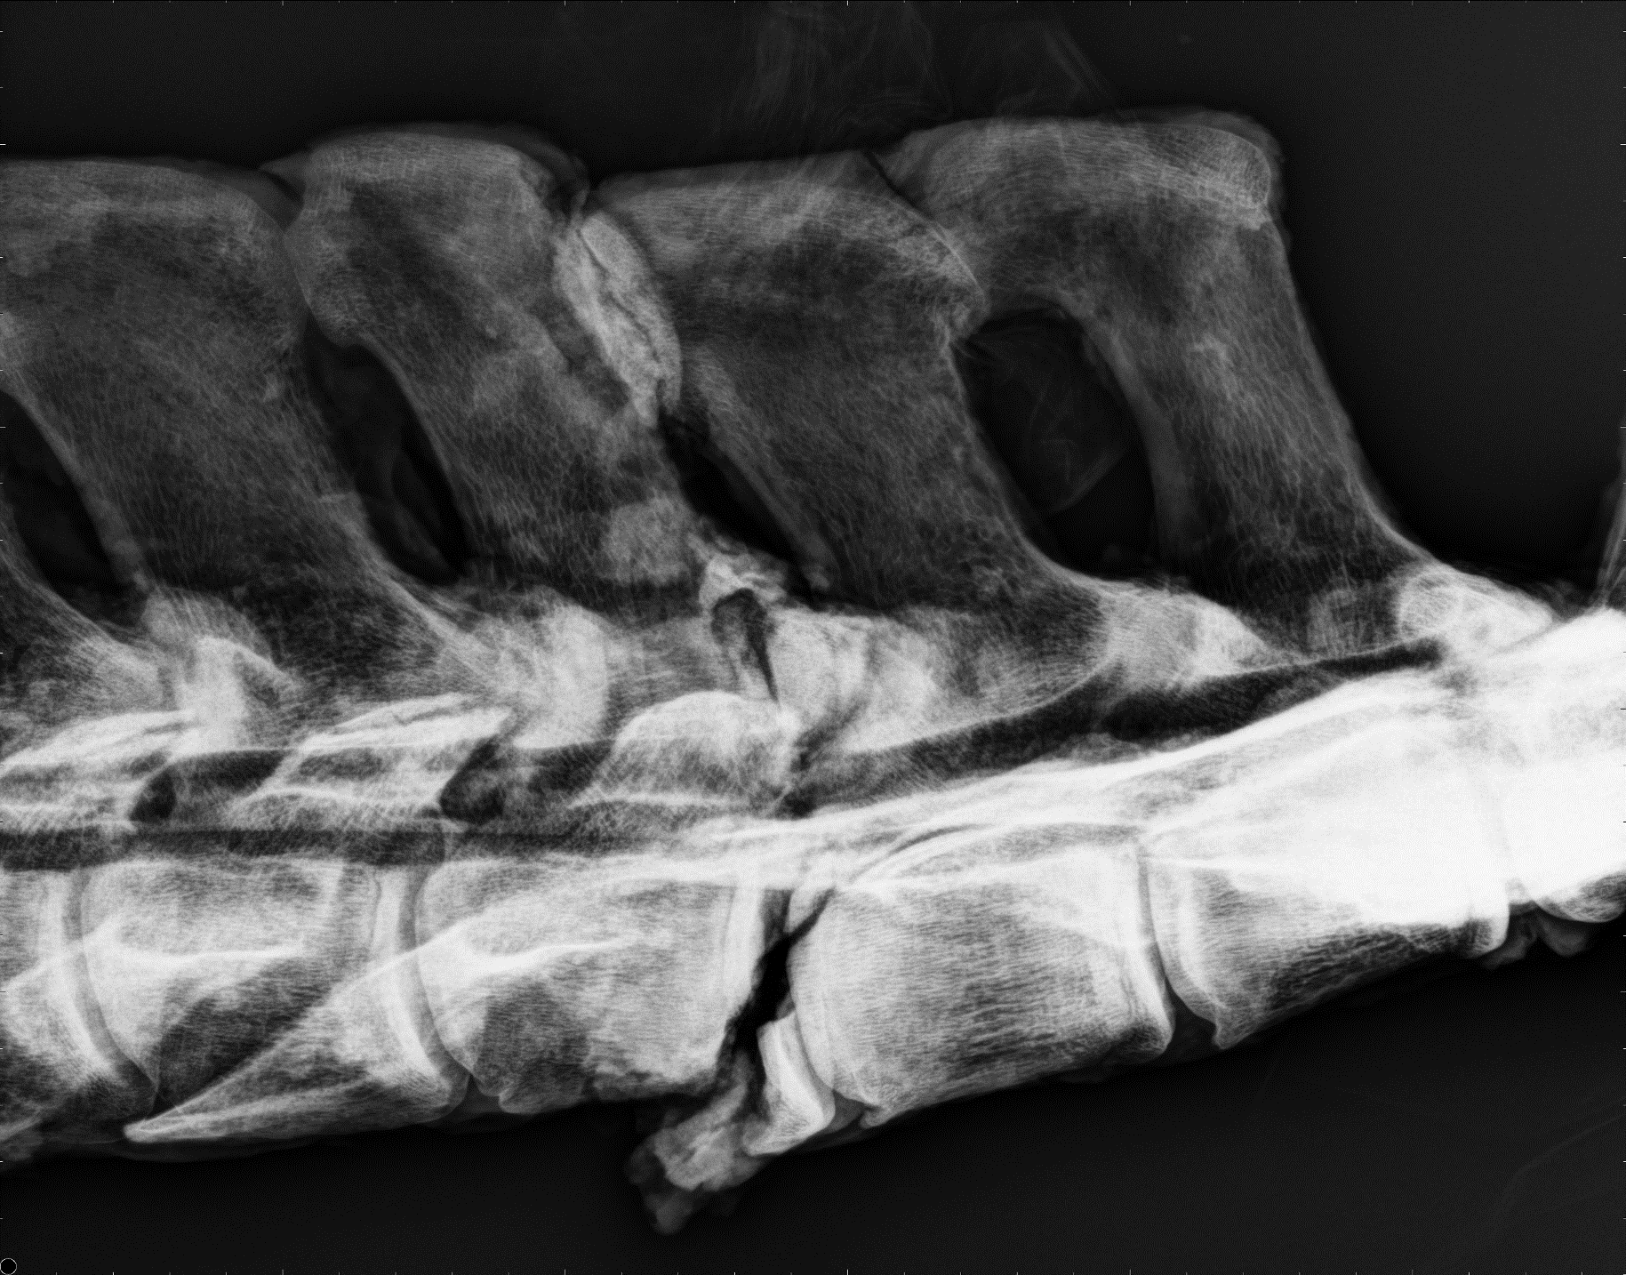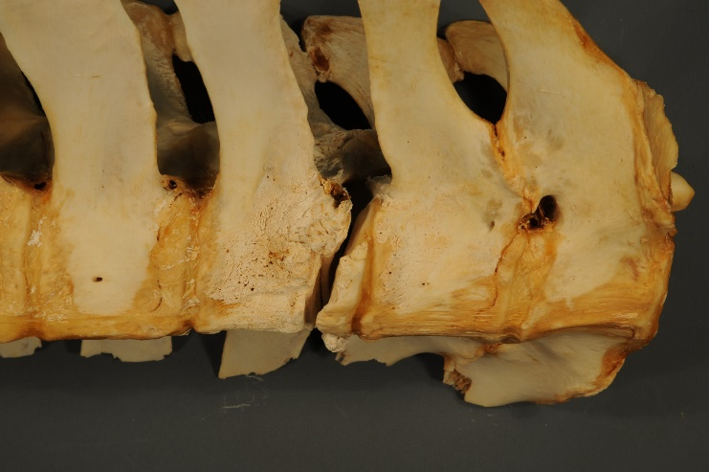
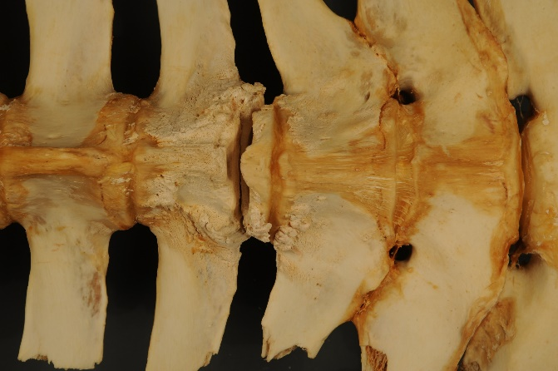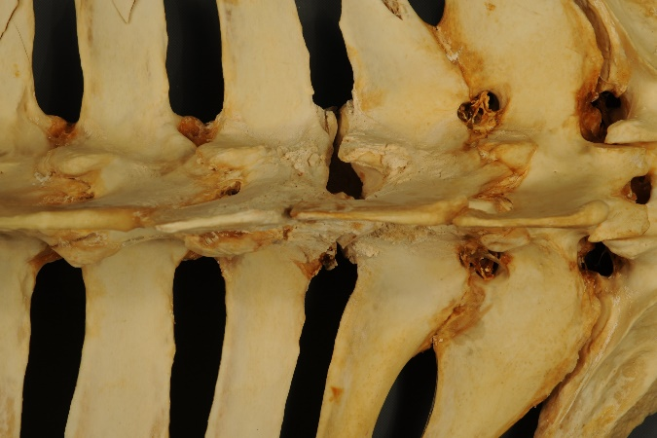
References
Racehorse Catastrophic Injury References (not a complete list)
July, 2022
Continuing Education Modules:
https://horsemenu.mclms.net/en/
https://vorl.vetmed.ucdavis.edu/continuing-education

References (not all possible references are listed):

Fetlock Proximal Sesamoid Bone Fractures
2023 | Training drives turnover rates in racehorse proximal sesamoid bones. Shaffer SK, Stover SM, Fyhrie DP. Scientific Reports 2023:13 https://doi.org/10.1038/s41598-022-26027-y https://www.nature.com/articles/s41598-022-26027-y.pdf
2022 | Exercise history predicts focal differences in bone volume fraction, mineral density and microdamage in racehorse proximal sesamoid bones. Shaffer SK, Garcia TC, Stover SM, Fyhrie DP. Journal of Orthopaedic Research 2022;Dec;40(12):2831-2842. doi: 10.1002/jor.25312. Epub 2022 Mar 19
2021 | In vitro motions of the medial and lateral proximal sesamoid bones under mid-stance load conditions are consistent with racehorse fracture configurations. Shaffer SK, Shelly K, Garcia TC, Samol MA, Hill AE, Fyhrie DP, Stover SM. J Biomech 2021 doi: 10.1016/j.jbiomech.2021.110888. Epub 2021 Nov 27.
2021 | Subchondral focal osteopenia associated with proximal sesamoid bone fracture in Thoroughbred racehorses. Shaffer SK, To CM, Garcia-Nolen TC, Fyhrie D, Uzal FA, Stover SM. Equine Vet J. 53(2):294-305. doi: 10.1111/evj.13291. Epub 2020 Jul 23.
2021 | Sudden death caused by spinal cord injury associated with vertebral fractures and fetlock failure in a Thoroughbred racehorse. Samol MA, Uzal FA, Blanchard PC, Arthur RM, Stover SM. Journal of Veterinary Diagnostic Investigation, 33(4):788-791
2013 | Diagnostic workup of upper-limb stress fractures and proximal sesamoid bone stress remodeling. Stover SM. Proceedings of the 59th Annual Convention of the American Association of Equine Practitioners, 59: 427-435.
2007 | Risk factors for proximal sesamoid bone fractures associated with exercise history and horseshoe characteristics in Thoroughbred racehorses. Anthenill LA, Stover SM, Gardner IA, Hill AE. American Journal of Veterinary Research, 68(7): 760-771.
2006 | Association between findings on palmarodorsal radiographic images and detection of a fracture in the proximal sesamoid bones of forelimbs obtained from cadavers of racing Thoroughbreds. Anthenill LA, Stover SM, Gardner IA, Hill AE, Lee CM, Anderson ML, Barr BC, Read DH, Johnson BJ, Woods LW, Daft BM, Kinde H, Moore JD, Farman CA, Odani JS, Pesavento PA, Uzal FA, Case JT, Ardans AA. American Journal of Veterinary Research, 67(5): 858-868.

Fetlock Suspensory Apparatus Injuries
2020 | Science-in-brief: Risk assessment for reducing injuries of the fetlock bones in Thoroughbred racehorses. Colgate VA; FRAT Group, Marr CM. Equine Vet J. 2020 Jul;52(4):482-488. doi: 10.1111/evj.13273. PMID: 32525619
2016 | Prevalence, location and symmetry of noncatastrophic ligamentous suspensory apparatus lesions in California Thoroughbred racehorses, and association of these lesions with catastrophic injuries. Hill AE, Gardner IA, Carpenter TE, Lee CM, Hitchens PL, Stover SM. Equine veterinary journal, 48(1): 27-32.
2010 | Comparison of macrostructural and microstructural bone features in Thoroughbred racehorses with and without midbody fracture of the proximal sesamoid bone.Anthenill LA, Gardner IA, Pool RR, Garcia TC, Stover SM. Am J Vet Res, 71(7): 755-65.
2004 | Effects of injury to the suspensory apparatus, exercise, and horseshoe characteristics on the risk of lateral condylar fracture and suspensory apparatus failure in forelimbs of thoroughbred racehorses. Hill AE, Gardner IA, Carpenter TE, Stover SM. Am J Vet Res, 65(11): 1508-17.
2003 | Evaluation of a stochastic Markov-chain model for the development of forelimb injuries in Thoroughbred racehorses. Hill AE, Carpenter TE, Gardner IA, Stover SM. American Journal of Veterinary Research, 64(3): 328-37.
2001 | Risk factors for and outcomes of noncatastrophic suspensory apparatus injury in Thoroughbred racehorses. Hill AE, Stover SM, Gardner IA, Kane AJ, Whitcomb MB, Emerson AG. Journal of the American Veterinary Medical Association, 218(7): 1136-44.
1998 | Hoof size, shape, and balance as possible risk factors for catastrophic musculoskeletal injury of Thoroughbred racehorses. Kane AJ, Stover SM, Gardner IA, Bock KB, Case JT, Johnson BJ, Anderson ML, Barr BC, Daft BM, Kinde H, Larochelle D, Moore J, Mysore J, Stoltz J, Woods L, Read DH, Ardans AA. American Journal of Veterinary Research, 59(12): 1545-52.
1996 | Horseshoe characteristics as possible risk factors for fatal musculoskeletal injury of thoroughbred racehorses. Kane AJ, Stover SM, Gardner IA, Case JT, Johnson BJ, Read DH, Ardans AA. American Journal of Veterinary Research, 57(8): 1147-52.
1996 | Postmortem evaluation of homotypic variation in shoe characteristics of 201 thoroughbred racehorses. Kane AJ, Stover SM, Gardner IA, Case JT, Johnson BJ, O'Brien MJ, Read DH, Ardans AA. American Journal of Veterinary Research, 57(8): 1141-6.

Cannon Bone Fractures
2017 | Preexisting lesions associated with complete diaphyseal fractures of the third metacarpal bone in 12 Thoroughbred racehorses. Gray S, Spriet M, Garcia TC, Uzal FA, Stover SM. Journal of Veterinary Diagnostic Investigation, 29(4): 437-441.
2006 | Subchondral bone failure in overload arthrosis: A scanning electron microscopic study in horses. Norrdin RW, Stover SM. J Musculoskelet Neuronal Interact, 6(3): 251-257.
2003 | Biomechanical investigation of the association between suspensory ligament injury and lateral condylar fracture in thoroughbred racehorses. Le Jeune SS, Macdonald MH, Stover SM, Taylor KT, Gerdes M. Vet Surg, 32(6): 585-97.

Humeral Fractures
2013 | Diagnostic workup of upper-limb stress fractures and proximal sesamoid bone stress remodeling. Stover SM. Proceedings of the 59th Annual Convention of the American Association of Equine Practitioners, 59: 427-435.
2013 | Humeral stress remodelling locations differ in Thoroughbred racehorses training and racing on dirt compared to synthetic racetrack surfaces. Dimock AN, Hoffman KD, Puchalski SM, Stover SM. Equine Veterinary Journal, 45(2): 176-181.
2009 | Material properties are related to stress fracture callus and porosity of cortical bone tissue at affected and unaffected sites. Entwistle RC, Sammons SC, Bigley RF, Hazelwood SJ, Fyhrie DP, Gibeling JC, Stover SM. J Orthop Res, 27(10): 1272-9.
1998 | Association between long periods without high-speed workouts and risk of complete humeral or pelvic fracture in thoroughbred racehorses: 54 cases (1991-1994).Carrier TK, Estberg L, Stover SM, Gardner IA, Johnson BJ, Read DH, Ardans AA. Journal of the American Veterinary Medical Association, 212(10): 1582-7.
1992 | An association between complete and incomplete stress fractures of the humerus in racehorses. Stover SM, Johnson BJ, Daft BM, Read DH, Anderson M, Barr BC, Kinde H, Moore J, Stoltz J, Ardans AA. Equine Veterinary Journal, 24(4): 260-3.

Scapular Fractures
2012 | Case-control study of high-speed exercise history of Thoroughbred and Quarter Horse racehorses that died related to a complete scapular fracture. Vallance SA, Entwistle RC, Gardner IA, Hitchens PL, Stover SM. Equine Veterinary Journal, 45(3): 284-292.
2012 | Characteristics of Thoroughbred and Quarter Horse racehorses that sustained a complete scapular fracture. Vallance SA, Case JT, Entwistle RC, Barr BC, Moore J, Anderson ML, Arthur RM, Stover SM. Equine Vet J, 44(4): 425-431.
2011 | Catastrophic scapular fractures in Californian racehorses: Pathology, morphometry and bone density.Vallance SA, Spriet M, Stover SM. Equine Vet J, 43(6): 676-685.

Tibial Fractures
2020 | Characteristics of complete tibial fractures in California racehorses. Samol MA, Uzal FA, Hill AE, Arthur RM, Stover SM. Equine Vet J. 2020 Oct 29. doi: 10.1111/evj.13375. Online ahead of print. PMID: 33119186

Pelvic Fractures
1999 | Pathologic changes in the lumbosacral vertebrae and pelvis in Thoroughbred racehorses.Haussler KK, Stover SM, Willits NH. American Journal of Veterinary Research, 60(2): 143-53.
1998 | Stress fractures of the vertebral lamina and pelvis in Thoroughbred racehorses. Haussler KK, Stover SM. Equine Veterinary Journal, 30(5): 374-81.
1998 | Association between long periods without high-speed workouts and risk of complete humeral or pelvic fracture in thoroughbred racehorses: 54 cases (1991-1994). Carrier TK, Estberg L, Stover SM, Gardner IA, Johnson BJ, Read DH, Ardans AA. Journal of the American Veterinary Medical Association, 212(10): 1582-7.
1996 | Oblique views of the ilium and the scintigraphic appearance of stress fractures of the ilium.Hornof WJ, Stover SM, Koblik PD, Arthur RM. Equine Veterinary Journal, 28(5): 355-8.

Lumbar (Back) Fractures
2015 | Caudal lumbar vertebral fractures in California Quarter Horse and Thoroughbred racehorses. Collar EM, Zavodovskaya R, Spriet M, Hitchens PL, Wisner T, Uzal FA, Stover SM. Equine veterinary journal, 47(5): 573-9.
1999 | Pathologic changes in the lumbosacral vertebrae and pelvis in Thoroughbred racehorses.Haussler KK, Stover SM, Willits NH. American Journal of Veterinary Research, 60(2): 143-53.
1998 | Stress fractures of the vertebral lamina and pelvis in Thoroughbred racehorses.Haussler KK, Stover SM. Equine Veterinary Journal, 30(5): 374-81.

Sudden Death
2017 | Sudden death in racehorses: postmortem examination protocol.  Diab SS, Poppenga R, Uzal FA. J Vet Diagn Invest. 2017 Jul;29(4):442-449. doi: 10.1177/1040638716687004.x
2011 | Sudden death in racing Thoroughbred horses: an international multicentre study of post mortem findings. Lyle CH, Uzal FA, McGorum BC, Aida H, Blissitt KJ, Case JT, Charles JT, Gardner I, Horadagoda N, Kusano K, Lam K, Pack JD, Parkin TD, Slocombe RF, Stewart BD, Boden LA. Equine Vet J. 2011 May;43(3):324-31. doi: 10.1111/j.2042-3306.2010.00164.x

General Catastrophic Musculoskeletal Injury and Factors Related to Injury
2018 | Relationship between historical lameness, medication usage, surgery, and exercise with catastrophic musculoskeletal injury in racehorses. Hitchens PL, Hill AE, Stover SM. Frontiers in Veterinary Science, 2018(7): 1-10.
2012 | Fatal Musculoskeletal Injuries of Quarter Horse Racehorses: 314 cases (1990-2007). Sarrafian TL, Case JT, Kinde H, Daft BM, Read DH, Moore JD, Uzal FA, Stover SM. Journal of the American Veterinary Medical Association, 241(7): 935-942.
2003 | The Epidemiology of Thoroughbred Racehorse Injuries. Stover SM. Clinical Techniques in Equine Practice, 2(4):312-322.
1998 | A case-crossover study of intensive racing and training schedules and risk of catastrophic musculoskeletal injury and lay-up in California thoroughbred racehorses. Estberg L, Gardner IA, Stover SM, Johnson BJ. Preventative Veterinary Medicine, 33(1-4): 159-70.
1998 | Relationship between race start characteristics and risk of catastrophic injury in thoroughbreds: 78 cases (1992). Estberg L, Stover SM, Gardner IA, Johnson BJ, Jack RA, Case JT, Ardans A, Read DH, Anderson ML, Barr BC, Daft BM, Kinde H, Moore J, Stoltz J, Woods L. Journal of the American Veterinary Medical Association, 212(4): 544-9.
1996 | High-speed exercise history and catastrophic racing fracture in thoroughbreds. Estberg L, Stover SM, Gardner IA, Drake CM, Johnson B, Ardans A. American Journal of Veterinary Research, 57(11): 1549-55.
1996 | Fatal musculoskeletal injuries incurred during racing and training in thoroughbreds. Estberg L, Stover SM, Gardner IA, Johnson BJ, Case JT, Ardans A, Read DH, Anderson ML, Barr BC, Daft BM, Kinde H, Moore J, Stoltz J, Woods LW. Journal of the American Veterinary Medical Association, 208(1): 92-6.
1995 | Cumulative racing-speed exercise distance cluster as a risk factor for fatal musculoskeletal injury in Thoroughbred racehorses in California.Estberg L, Gardner IA, Stover SM, Johnson BJ, Case JT, Ardans A. Preventive Veterinary Medicine, 24: 253-63.
1994 | Causes of death in racehorses over a 2 year period. Johnson BJ, Stover SM, Daft BM, Kinde H, Read DH, Barr BC, Anderson M, Moore J, Woods L, Stoltz J, Blanchard P. Equine Veterinary Journal, 26(4): 327-30.

Post Mortem Examination
2017 | Diagnostic approach to catastrophic musculoskeletal injuries in racehorses. Diab SS, Stover S, Carvallo F, Nyaoke AC, Moore J, Hill A, Arthur R, Uzal FA. Journal of Veterinary Diagnostic Investigation, 29(4): 405-413.
2017 | Nomenclature, classification, and documentation of catastrophic fractures and associated pre-existing injuries in racehorses. Stover, SM. Journal of Veterinary Diagnostic Investigation, 29(4): 396-404.

Jockey Injuries
2014 | The role of catastrophic injury or sudden death of the horse in race-day jockey falls and injuries in California, 2007-2012. Hitchens PL, Hill AE, Stover SM. Equine veterinary journal, 48: 50-56.
2013 | Jockey falls, injuries and fatalities associated with Thoroughbred and Quarter Horse racing in California, 2007-2011. Hitchens PL, Hill AE, Stover SM. Orthopaedic Journal of Sports Medicine, 1(1): 2325967113492625.

APPENDIX – BONE DIAGRAMS

Acc # Scapula - Left
Date
CC

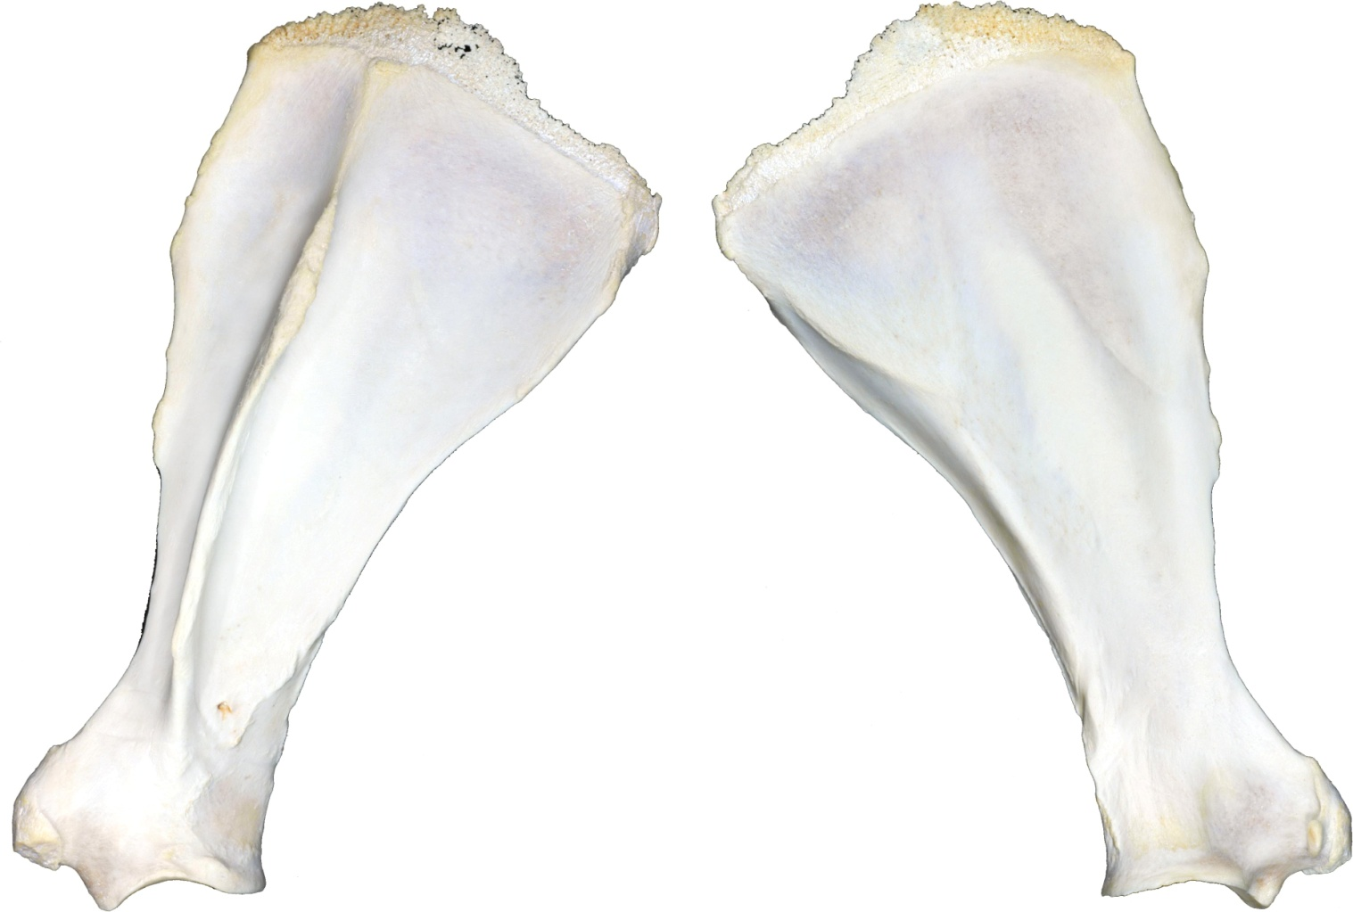
Nature:
 | Open |  | Closed
 | Simple |  | Comminuted
 | Complete |  | Incomplete
 | Displaced |  | Non-displaced
 | Articular |  | Non-articular

Location:
Body
Neck
Other

Configuration:
 | Axial (longitudinal) |  | Butterfly
 | Transverse |  | Oblique
 | Segmental |  | 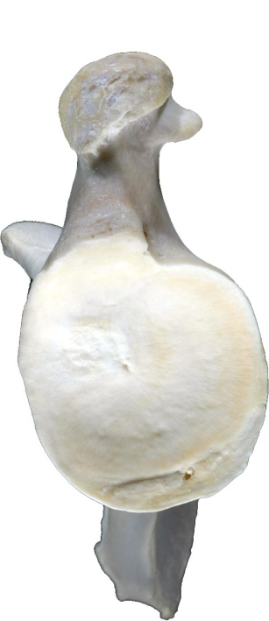

Pre-existing callus:
 | Yes |  | No
 | Unable to evaluate

Legend:
Callus
Incomplete Fx
M Missing fragments

Acc # Scapula - Right
Date
CC

Nature:
 | Open |  | 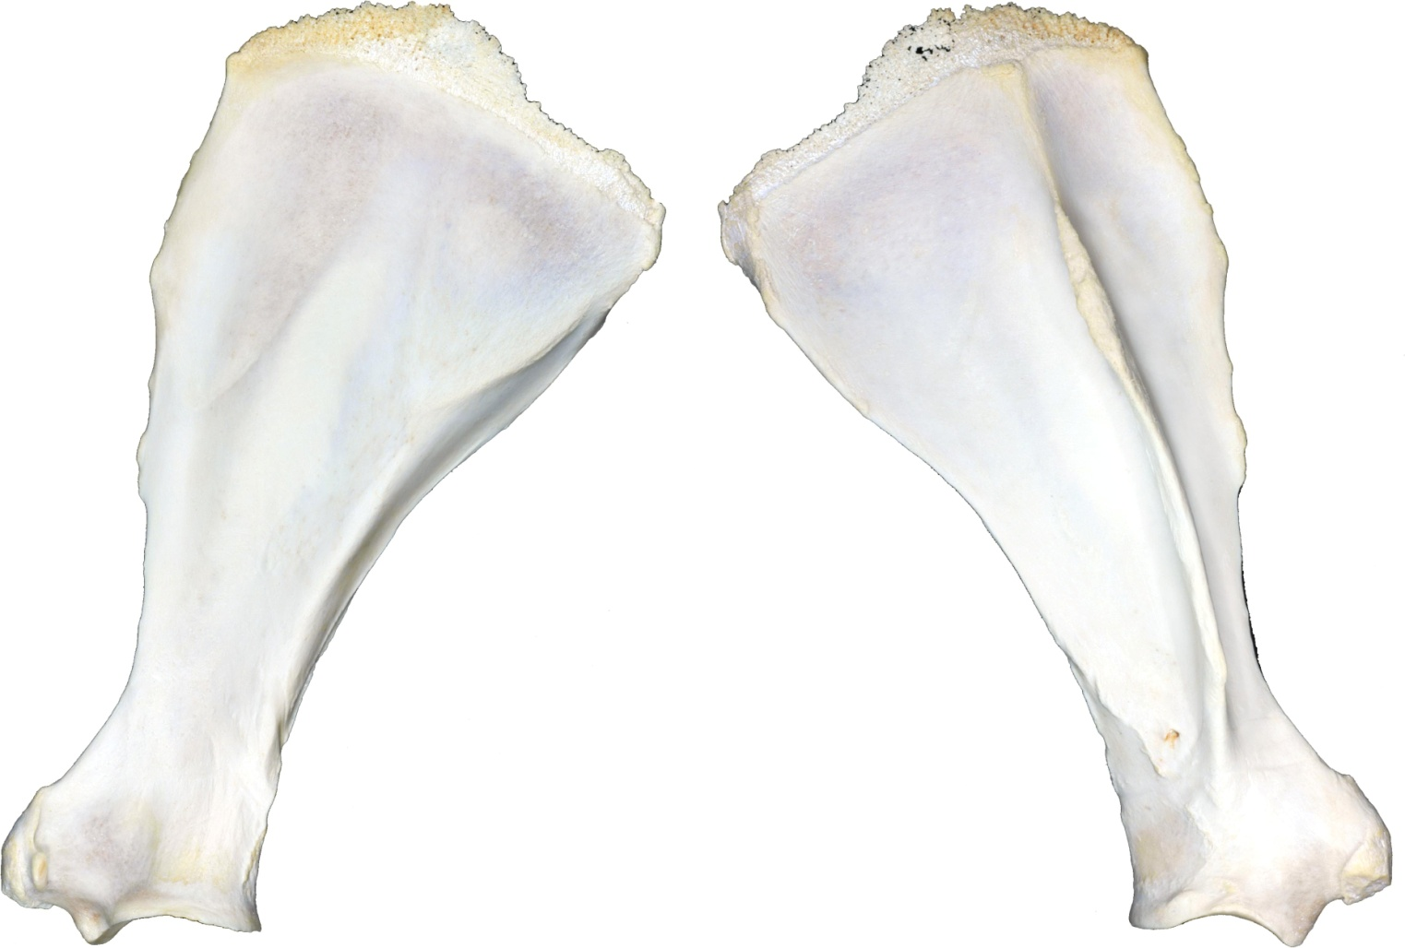  Closed
 | Simple |  | Comminuted
 | Complete |  | Incomplete
 | Displaced |  | Non-displaced
 | Articular |  | Non-articular

Location:
Body
Neck
Other

Configuration:
 | Axial (longitudinal) |  | Butterfly
 | Transverse |  | Oblique
 | Segmental |  | 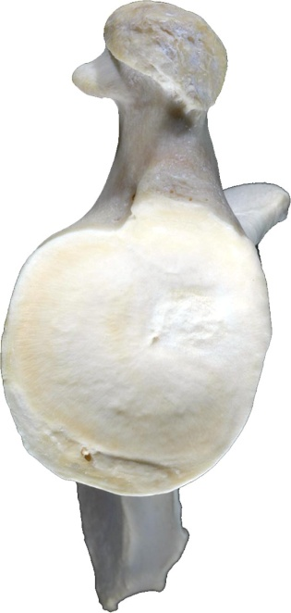

Pre-existing callus:
 | Yes |  | No
 | Unable to evaluate

Legend:
Callus
Incomplete Fx
M Missing fragments

Acc # Humerus - Left
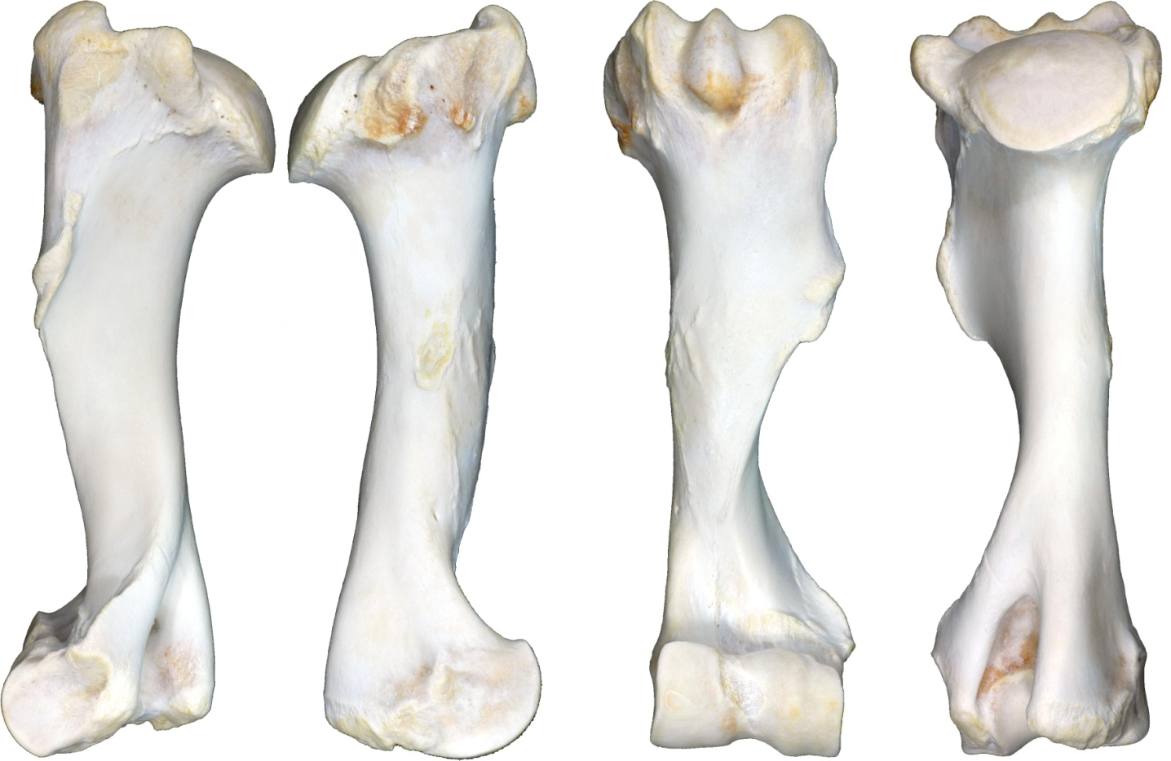
Date
CC
Nature:
 | Open |  | Closed
 | Simple |  | Comminuted
 | Complete |  | Incomplete
 | Displaced |  | Non-displaced
 | Articular |  | Non-articular

Location:
 | Proximal Epiphyseal |  | Distal Epiphyseal
 | Proximal Metaphyseal |  | Distal Metaphyseal
 | Proximal Physeal |  | Distal Physeal
 | Diaphyseal
Configuration:
 | Axial (longitudinal) |  | Butterfly
 | Transverse |  | Oblique
 | Segmental
Direction:
 | Proximodorsal-Distopalmar |  | 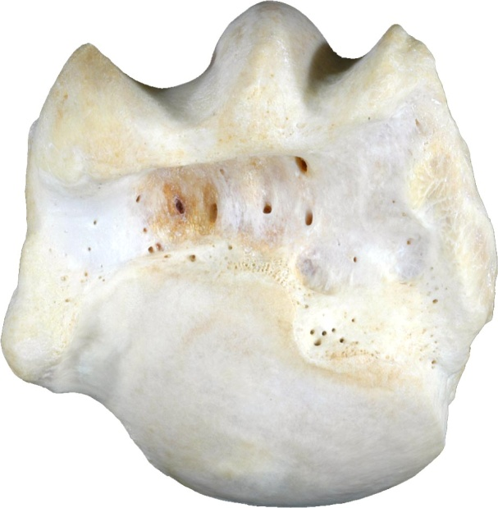  Proximopalmar-Distodorsal
 | Proximolateral-Distomedial |  | 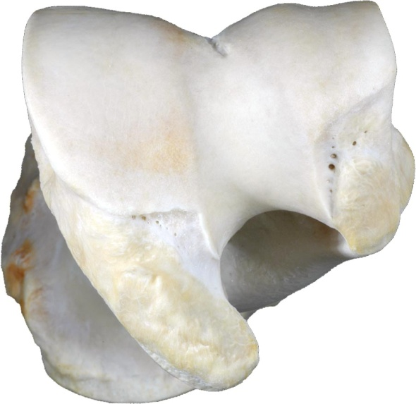  Proximomedial-Distolateral
 | Sagittal |  | Dorsal plane (mediolateral)
Pre-existing callus:
 | Yes |  | No
 | Unable to evaluate

Legend:
Callus
Incomplete Fx
M Missing fragments
Acc # Humerus - Right
Date
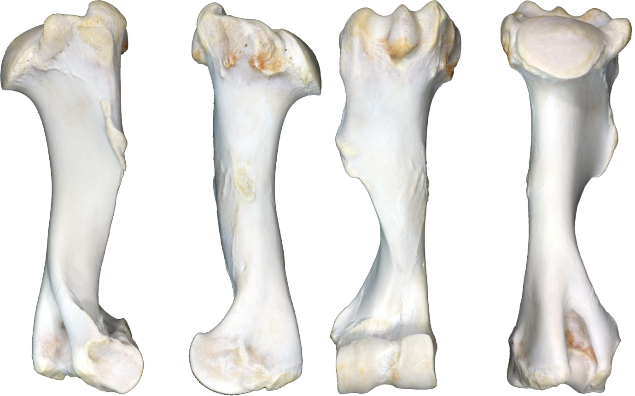
CC
Nature:
 | Open |  | Closed
 | Simple |  | Comminuted
 | Complete |  | Incomplete
 | Displaced |  | Non-displaced
 | Articular |  | Non-articular

Location:
 | Proximal Epiphyseal |  | Distal Epiphyseal
 | Proximal Metaphyseal |  | Distal Metaphyseal
 | Proximal Physeal |  | Distal Physeal
 | Diaphyseal
Configuration:
 | Axial (longitudinal) |  | Butterfly
 | Transverse |  | Oblique
 | Segmental

Direction:
 | Proximodorsal-Distopalmar |  | Proximopalmar-Distodorsal
 | Proximolateral-Distomedial |  | 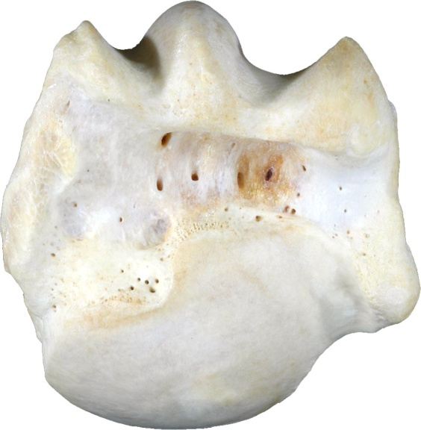  Proximomedial-Distolateral
 | Sagittal |  | 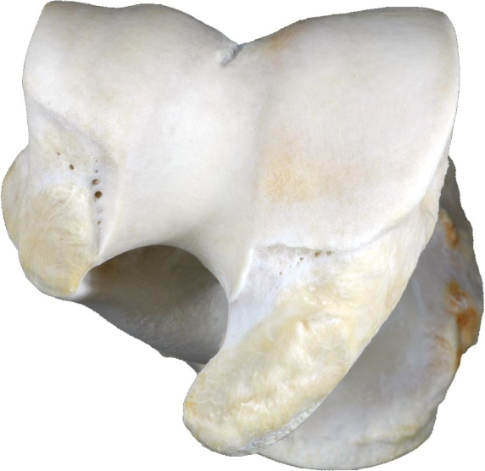  Dorsal plane (mediolateral)

Pre-existing callus:
 | Yes |  | No
 | Unable to evaluate
Legend:
Callus
Incomplete Fx
M Missing fragments
Acc # Ulna and Radius - Left
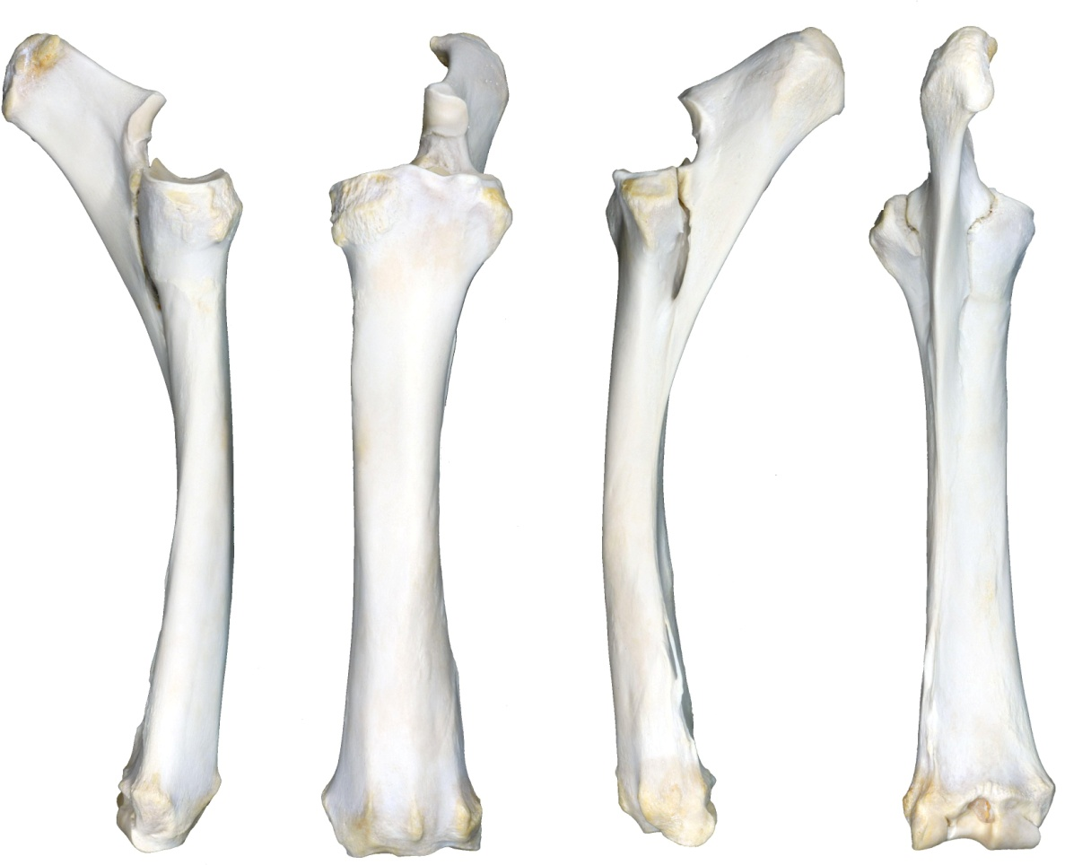
Date
CC
Nature:
 | Open |  | Closed
 | Simple |  | Comminuted
 | Complete |  | Incomplete
 | Displaced |  | Non-displaced
 | Articular |  | Non-articular

Location:
 | Proximal Epiphyseal |  | Distal Epiphyseal
 | Proximal Metaphyseal |  | Distal Metaphyseal
 | Proximal Physeal |  | Distal Physeal
 | Diaphyseal

Configuration:
 | Axial (longitudinal) |  | Butterfly
 | Transverse |  | Oblique
 | Segmental

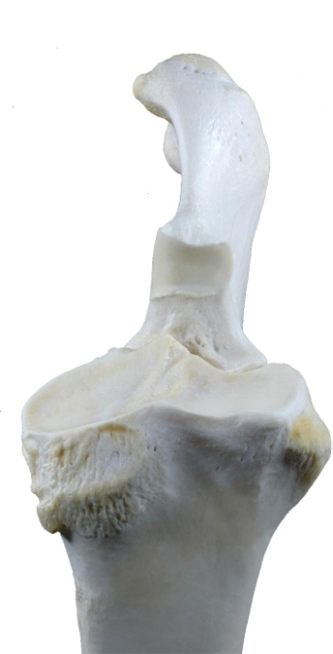
Direction:
 | Proximodorsal-Distopalmar |  | Proximopalmar-Distodorsal
 | Proximolateral-Distomedial |  | Proximomedial-Distolateral
 | Sagittal |  | Dorsal plane (mediolateral)

Pre-existing callus:
 | Yes |  | 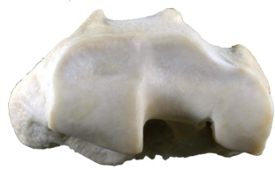  No
 | Unable to evaluate

Legend:
Callus
Incomplete Fx
M Missing fragments
Acc # Ulna and Radius - Right
Date
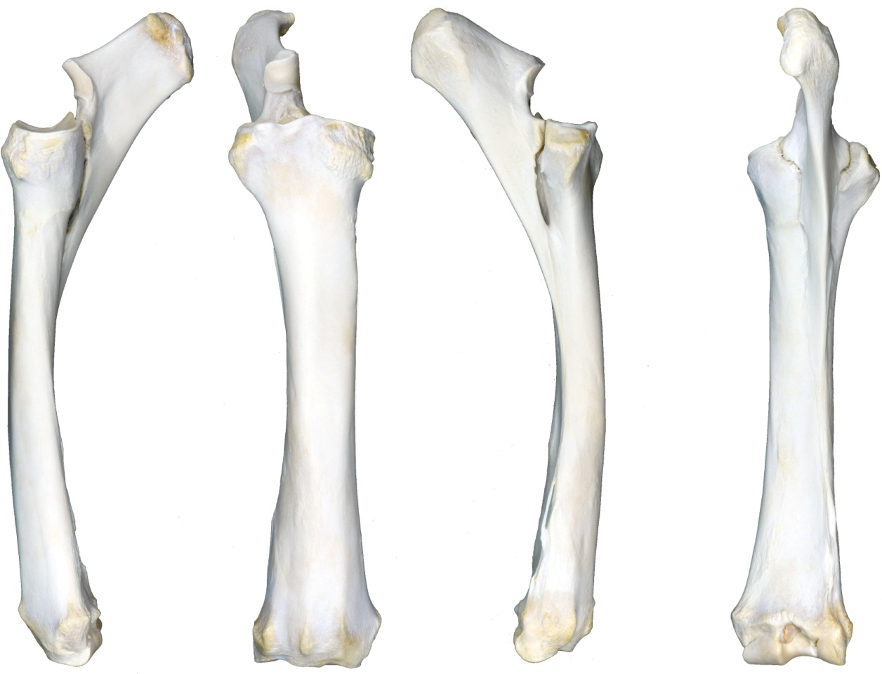
CC
Nature:
 | Open |  | Closed
 | Simple |  | Comminuted
 | Complete |  | Incomplete
 | Displaced |  | Non-displaced
 | Articular |  | Non-articular

Location:
 | Proximal Epiphyseal |  | Distal Epiphyseal
 | Proximal Metaphyseal |  | Distal Metaphyseal
 | Proximal Physeal |  | Distal Physeal
 | Diaphyseal

Configuration:
 | Axial (longitudinal) |  | Butterfly
 | Transverse |  | Oblique
 | Segmental

Direction:
 | Proximodorsal-Distopalmar |  | 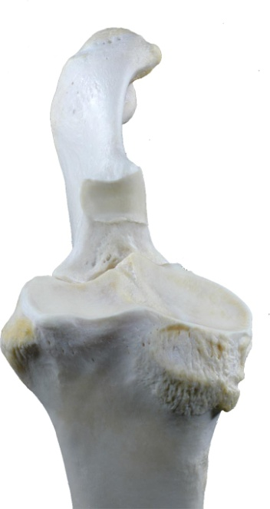  Proximopalmar-Distodorsal
 | Proximolateral-Distomedial |  | Proximomedial-Distolateral
 | Sagittal |  | Dorsal plane (mediolateral)

Pre-existing callus:
 | Yes |  | No
 | Unable to evaluate |  | 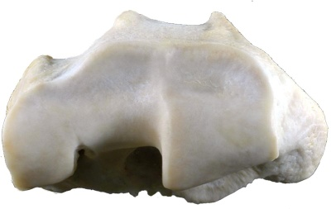
Legend:
Callus
Incomplete Fx
M Missing fragments
Acc # Carpus - Left
Date
CC

Nature:
 | Open |  | 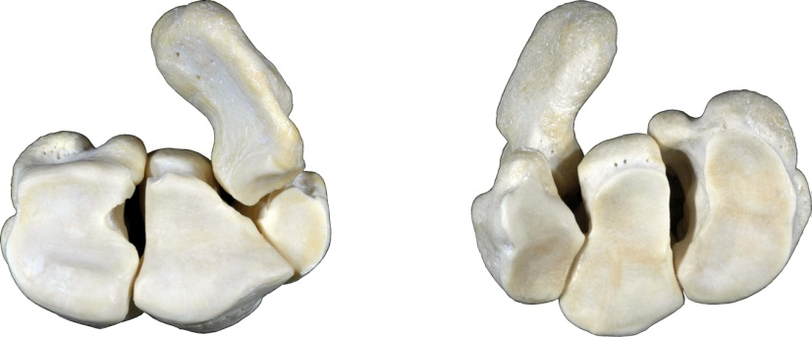  Closed
 | Simple |  | 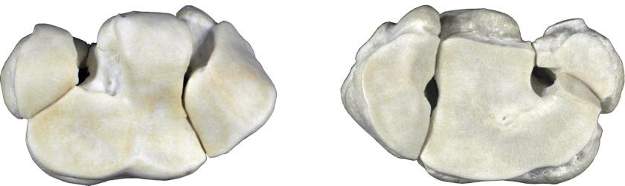  Comminuted
 | Complete |  | Incomplete
 | Displaced |  | Non-displaced
 | Articular |  | Non-articular
 | Slab

Subchondral lesion
 | Yes |  | No
 | Unable to evaluate

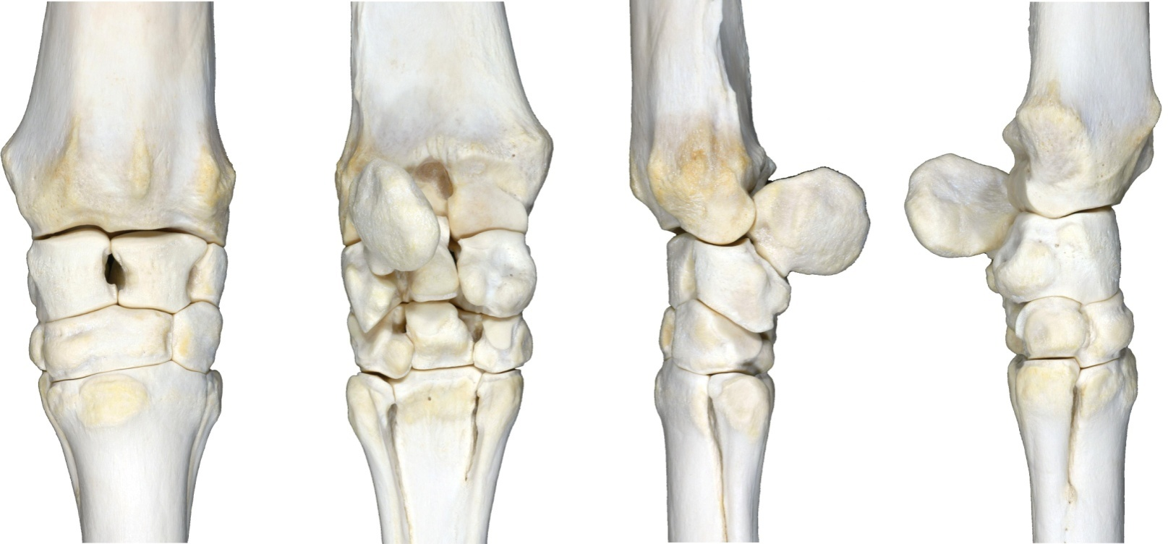
Pre-existing callus
 | Yes |  | No
 | Unable to evaluate

Legend:
Callus
Incomplete Fx
M Missing fragments

Acc # Carpus - Right
Date
CC

Nature:
 | Open |  | Closed
 | Simple |  | 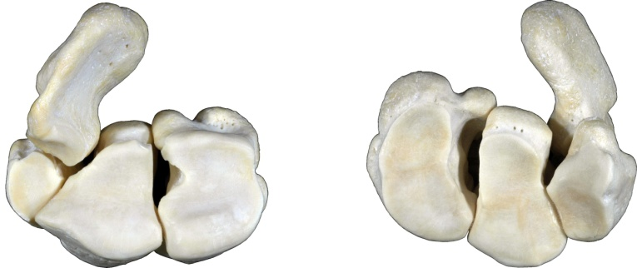  Comminuted
 | Complete |  | 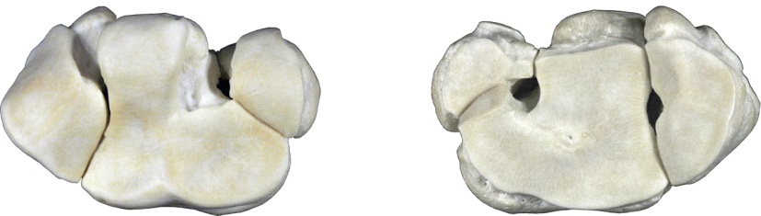  Incomplete
 | Displaced |  | Non-displaced
 | Articular |  | Non-articular
 | Slab

Subchondral lesion
 | Yes |  | No
 | Unable to evaluate

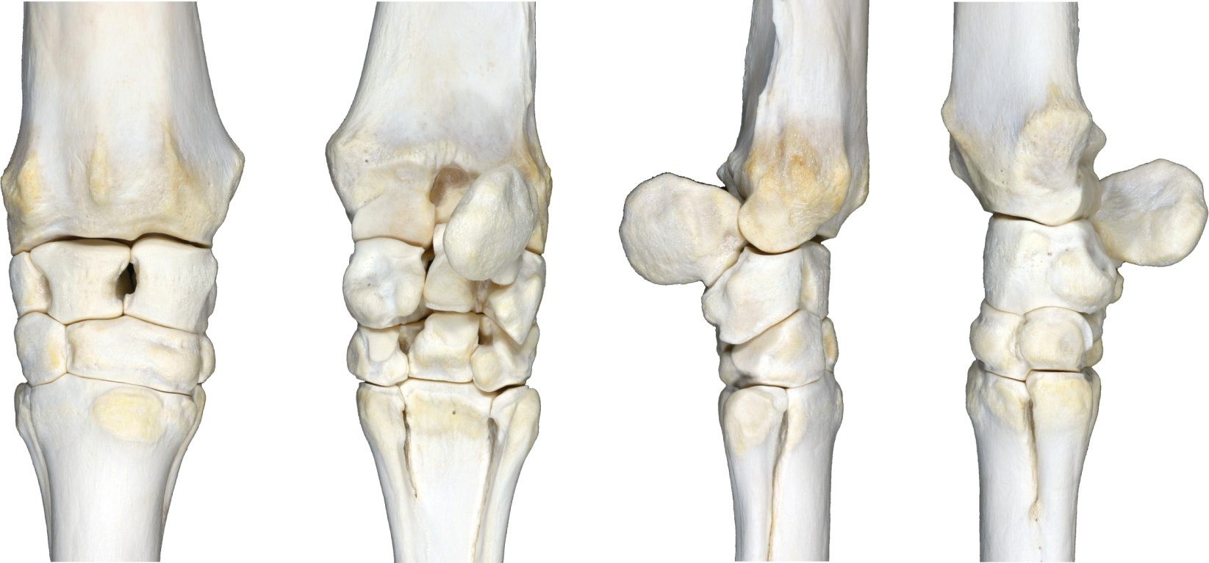
Pre-existing callus:
 | Yes |  | No
 | Unable to evaluate

Legend:
Callus
Incomplete Fx
M Missing fragments

Acc # Metacarpal Bones - Left
Date
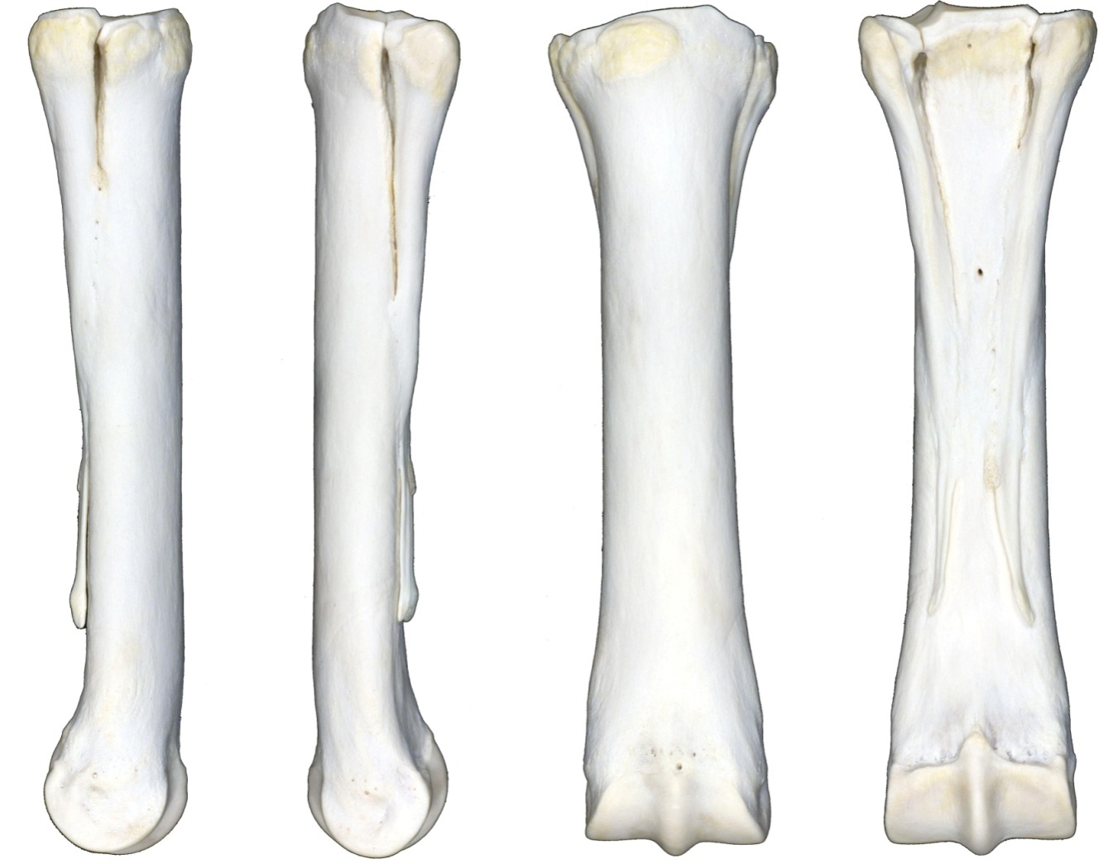
CC
Nature:
 | Open |  | Closed
 | Simple |  | Comminuted
 | Complete |  | Incomplete
 | Displaced |  | Non-displaced
 | Articular |  | Non-articular
Location:
 | Proximal Epiphyseal |  | Distal Epiphyseal
 | Proximal Metaphyseal |  | Distal Metaphyseal
 | Proximal Physeal |  | Distal Physeal
 | Diaphyseal
 | Condylar
 | Medial ____ cm
 | Lateral ____ cm
Configuration:
 | Axial (longitudinal) |  | Butterfly
 | Transverse |  | Oblique
 | Segmental
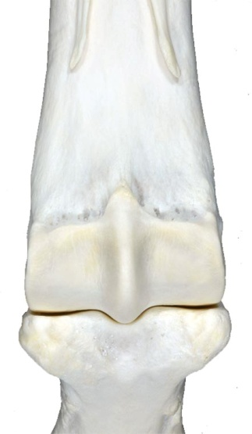
Direction:
 | Proximodorsal-Distopalmar |  | Proximopalmar-Distodorsal
 | Proximolateral-Distomedial |  | Proximomedial-Distolateral
 | Sagittal |  | Dorsal plane (mediolateral)
Subchondral lesion
 | Yes |  | No
 | Unable to evaluate
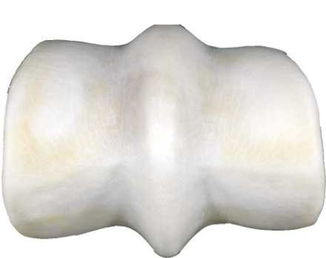
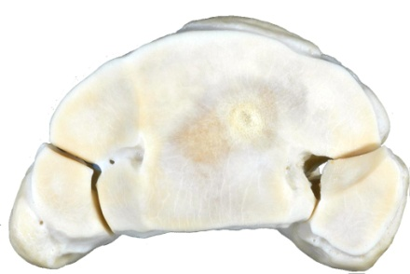
Pre-existing callus:
 | Yes |  | No
 | Unable to evaluate
Legend:
Callus;
----Incomplete Fx;
M Missing fragments
Acc # Metacarpal Bones - Right
Date
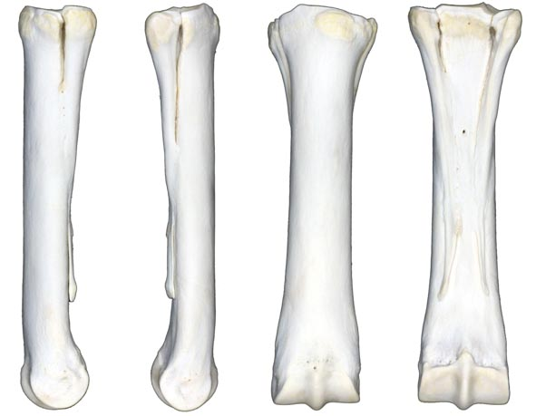
CC
Nature:
 | Open |  | Closed
 | Simple |  | Comminuted
 | Complete |  | Incomplete
 | Displaced |  | Non-displaced
 | Articular |  | Non-articular
Location:
 | Proximal Epiphyseal |  | Distal Epiphyseal
 | Proximal Metaphyseal |  | Distal Metaphyseal
 | Proximal Physeal |  | Distal Physeal
 | Diaphyseal
 | Condylar
 | Medial ____ cm
 | Lateral ____ cm
Configuration:
 | Axial (longitudinal) |  | Butterfly
 | Transverse |  | Oblique
 | Segmental
Direction:
 | Proximodorsal-Distopalmar |  | Proximopalmar-Distodorsal
 | Proximolateral-Distomedial |  | Proximomedial-Distolateral
 | Sagittal |  | Dorsal plane (mediolateral)
Subchondral lesion
 | Yes |  | No
 | Unable to evaluate
Pre-existing callus:
 | Yes |  | No
 | Unable to evaluate
Legend:
Callus;
----Incomplete Fx;
M Missing fragments
Acc # Proximal Sesamoid Bones
Date
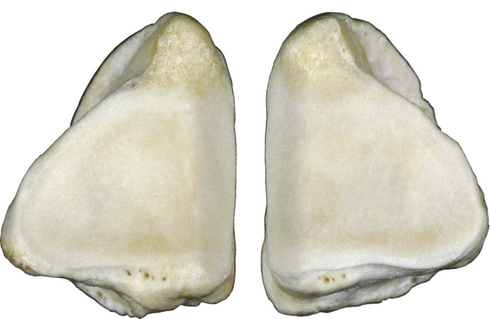
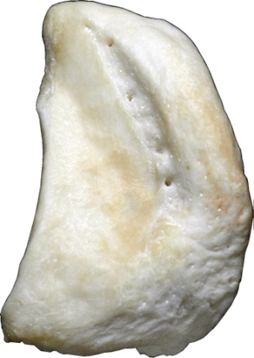
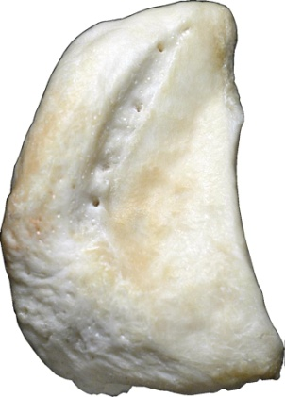
CC

Nature:
 | Open |  | Closed
 | Simple |  | Comminuted
 | Complete |  | Incomplete
 | Displaced |  | Non-displaced
 | Articular |  | Non-articular
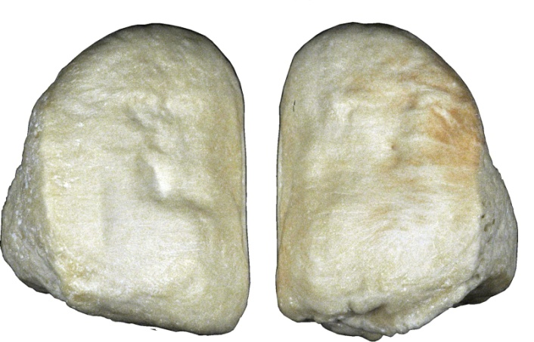
Location:
 | Apical |  | Avulsion
 | Mid Body
 | Basilar
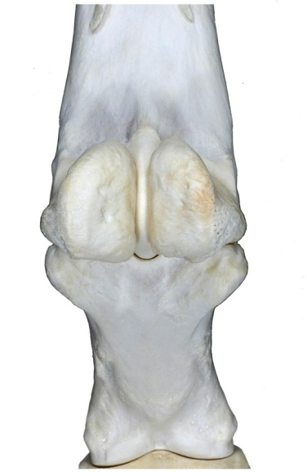
Configuration:
 | Axial (longitudinal) |  | Butterfly
 | Transverse |  | Oblique
 | Segmental
Distribution:
Axial
Abaxial
Subchondral lesion
 | Yes |  | No
 | Unable to evaluate
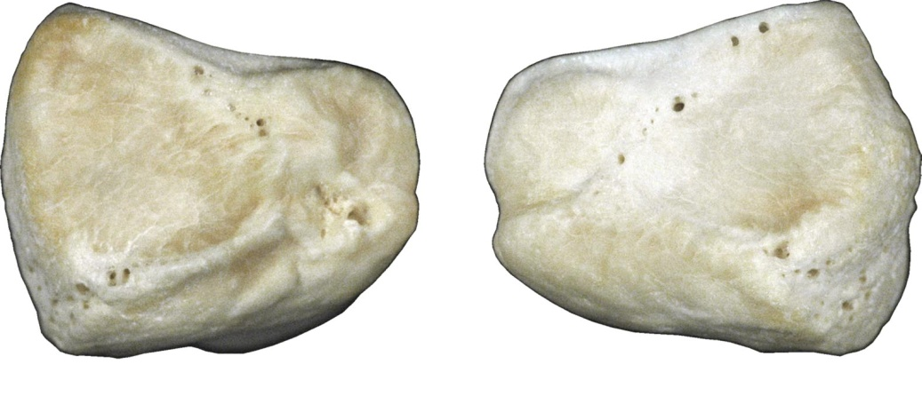
Pre-existing callus:
 | Yes |  | No
 | Unable to evaluate

Legend:
Callus
Incomplete Fx
M Missing fragments

Acc # Proximal Phalanx - Left
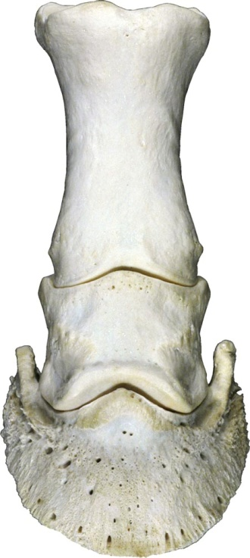
Date
CC
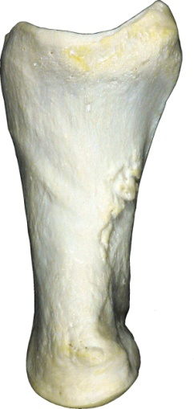
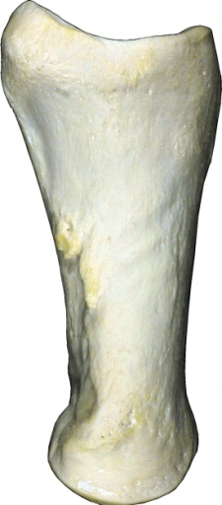
Nature:
 | Open |  | Closed
 | Simple |  | Comminuted
 | Complete |  | Incomplete
 | Displaced |  | Non-displaced
 | Articular |  | Non-articular
Location:
 | Proximal Epiphyseal |  | Distal Epiphyseal
 | Proximal Metaphyseal |  | Distal Metaphyseal
 | Proximal Physeal |  | Distal Physeal
 | Diaphyseal
Configuration:
 | Axial (longitudinal) |  | Butterfly
 | Transverse |  | Oblique
 | Segmental |  | 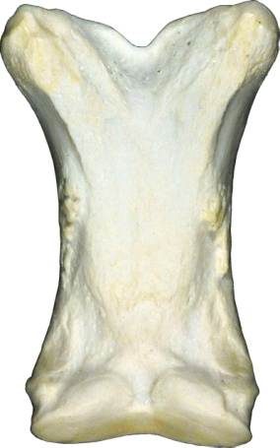  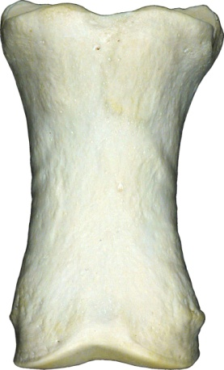  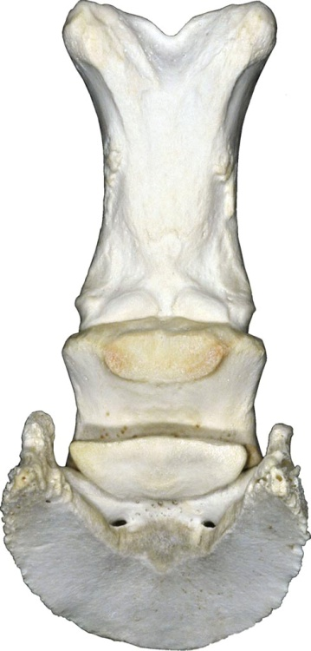
Direction:
 | Proximodorsal-Distopalmar |  | Proximopalmar-Distodorsal
 | Proximolateral-Distomedial |  | Proximomedial-Distolateral
 | Sagittal |  | Dorsal plane (mediolateral)
Subchondral lesion
 | Yes |  | No
 | Unable to evaluate
Pre-existing callus:
 | Yes |  | No
 | Unable to evaluate
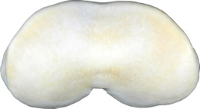
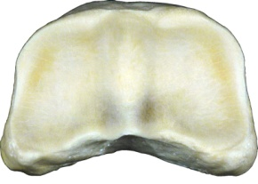
Legend:
Callus
Incomplete Fx;
M Missing fragments

Acc # Proximal Phalanx - Right
Date
CC

Nature:
 | Open |  | Closed
 | Simple |  | Comminuted
 | Complete |  | Incomplete
 | Displaced |  | Non-displaced
 | Articular |  | Non-articular
Location:
 | Proximal Epiphyseal |  | Distal Epiphyseal
 | Proximal Metaphyseal |  | Distal Metaphyseal
 | Proximal Physeal |  | Distal Physeal
 | Diaphyseal
Configuration:
 | Axial (longitudinal) |  | Butterfly
 | Transverse |  | Oblique
 | Segmental |  | 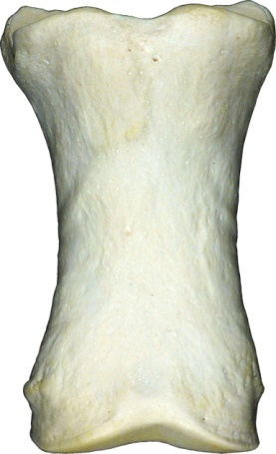
Direction:
 | Proximodorsal-Distopalmar |  | Proximopalmar-Distodorsal
 | Proximolateral-Distomedial |  | Proximomedial-Distolateral
 | Sagittal |  | Dorsal plane (mediolateral)
Subchondral lesion
 | Yes |  | No
 | Unable to evaluate
Pre-existing callus:
 | Yes |  | No
 | Unable to evaluate
Legend:
Callus
Incomplete Fx;
M Missing fragments

Acc # Middle Phalanx - Left
Date
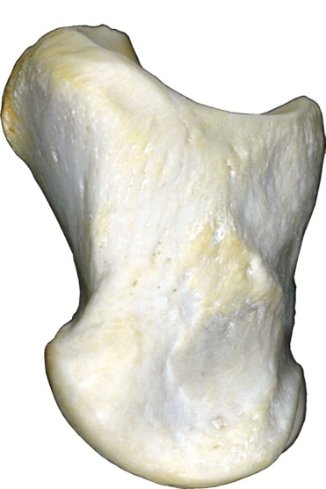
CC
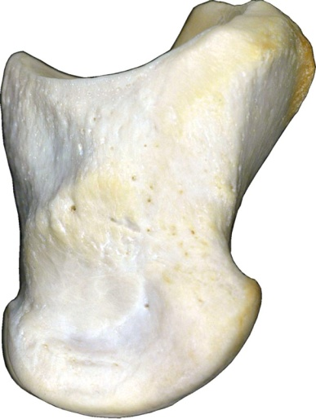
Nature:
 | Open |  | Closed
 | Simple |  | Comminuted
 | Complete |  | Incomplete
 | Displaced |  | Non-displaced
 | Articular |  | Non-articular
Location:
 | Proximal Epiphyseal |  | Distal Epiphyseal
 | Proximal Metaphyseal |  | Distal Metaphyseal
 | Proximal Physeal |  | Distal Physeal
 | Diaphyseal
Configuration:
 | Axial (longitudinal) |  | Butterfly
 | Transverse |  | Oblique
 | Segmental
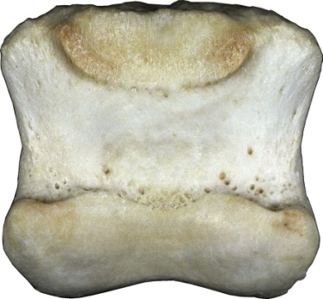
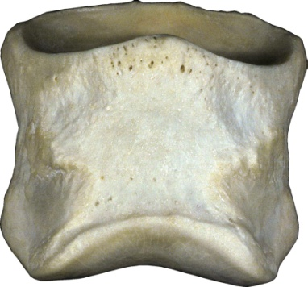
Direction:
 | Proximodorsal-Distopalmar |  | Proximopalmar-Distodorsal
 | Proximolateral-Distomedial |  | Proximomedial-Distolateral
 | Sagittal |  | Dorsal plane (mediolateral)
Subchondral lesion
 | Yes |  | No
 | Unable to evaluate
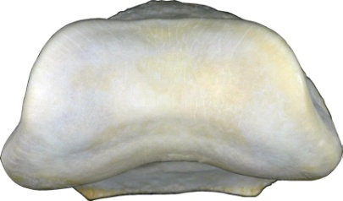
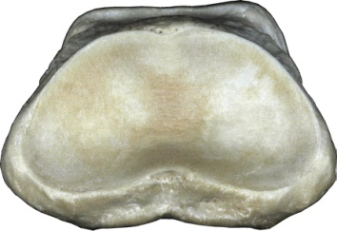
Pre-existing callus:
 | Yes |  | No
 | Unable to evaluate
Legend:
Callus
Incomplete Fx;
M Missing fragments

Acc # Middle Phalanx - Right
Date
CC
Nature:
 | Open |  | Closed
 | Simple |  | Comminuted
 | Complete |  | Incomplete
 | Displaced |  | Non-displaced
 | Articular |  | Non-articular
Location:
 | Proximal Epiphyseal |  | Distal Epiphyseal
 | Proximal Metaphyseal |  | Distal Metaphyseal
 | Proximal Physeal |  | Distal Physeal
 | Diaphyseal
Configuration:
 | Axial (longitudinal) |  | Butterfly
 | Transverse |  | Oblique
 | Segmental
Direction:
 | Proximodorsal-Distopalmar |  | Proximopalmar-Distodorsal
 | Proximolateral-Distomedial |  | Proximomedial-Distolateral
 | Sagittal |  | Dorsal plane (mediolateral)
Subchondral lesion
 | Yes |  | No
 | Unable to evaluate
Pre-existing callus:
 | Yes |  | No
 | Unable to evaluate

Callus
Incomplete Fx;
M Missing fragments

Acc # Distal Phalanx
Date
CC

Nature:
 | Open |  | Closed
 | Simple |  | Comminuted
 | Complete |  | Incomplete
 | Displaced |  | Non-displaced
 | Articular |  | Non-articular
 | Avulsion
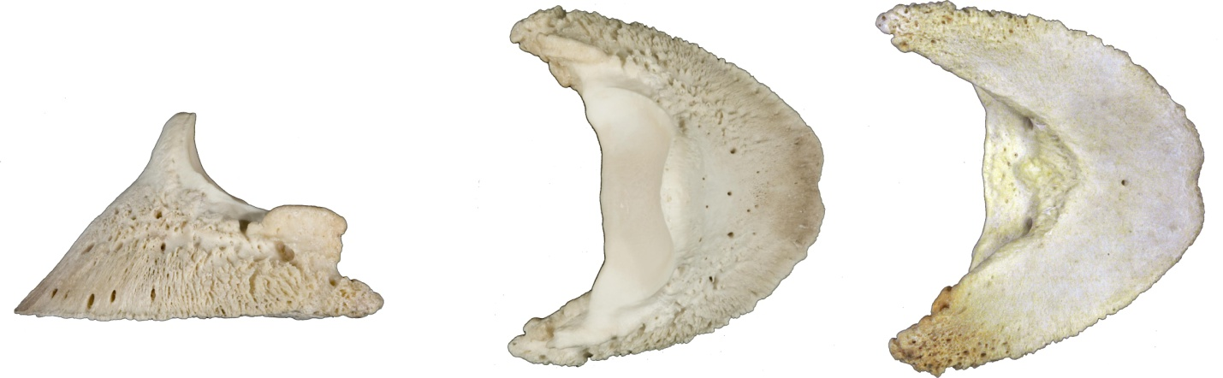
Configuration:
 | Axial (longitudinal) |  | Butterfly
 | Transverse |  | Oblique
 | Segmental

Direction:
 | Proximodorsal-Distopalmar |  | Proximopalmar-Distodorsal
 | Proximolateral-Distomedial |  | Proximomedial-Distolateral
 | Sagittal |  | Dorsal plane (mediolateral)

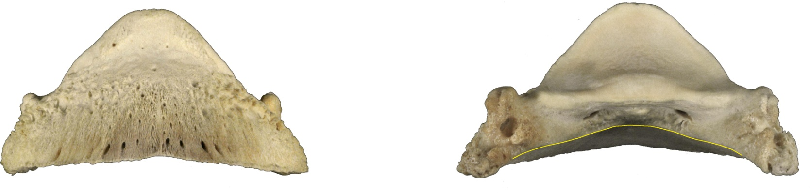
Legend:
Callus
Incomplete Fx
M Missing fragments

Acc # Distal Sesamoid Bone
Date (Navicular Bone)
CC

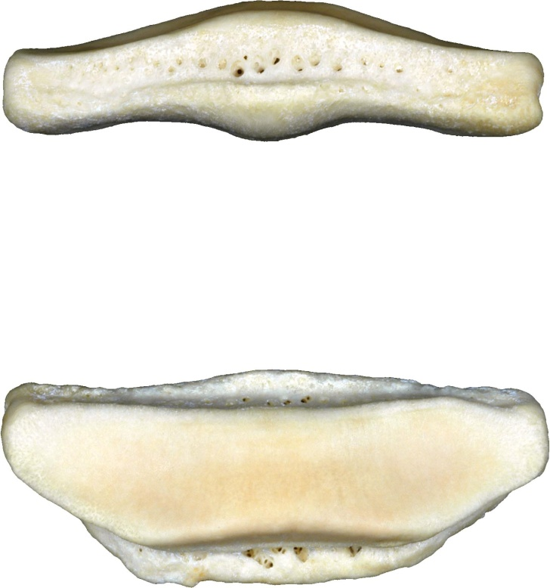
Nature:
 | Open |  | 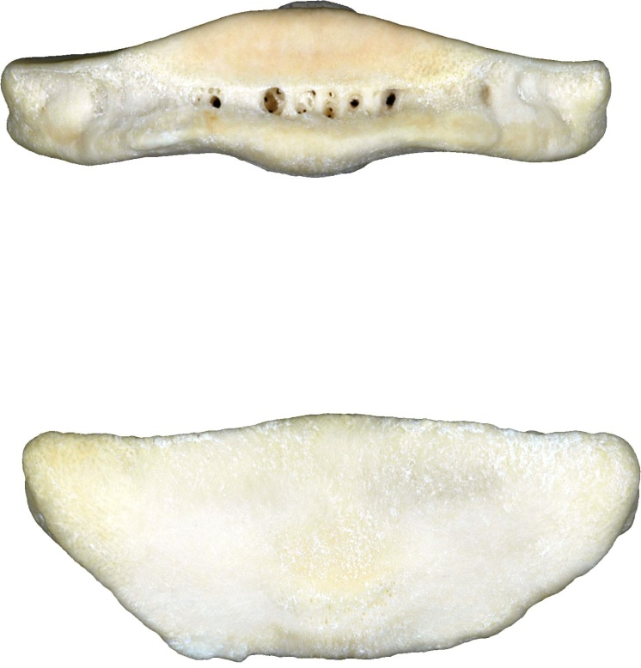  Closed
 | Simple |  | Comminuted
 | Complete |  | Incomplete
 | Displaced |  | Non-displaced
 | Articular |  | Non-articular
 | Avulsion

Configuration:
 | Axial (longitudinal) |  | Butterfly
 | Transverse |  | Oblique
 | Segmental

Direction:
 | Proximodorsal-Distopalmar |  | Proximopalmar-Distodorsal
 | Proximolateral-Distomedial |  | Proximomedial-Distolateral
 | Sagittal |  | Dorsal plane (mediolateral)

Legend:
Callus
Incomplete Fx
M Missing fragments

Acc # Pelvis, Dorsal
Date
CC

Nature:
 | Open |  | Closed
 | Simple |  | 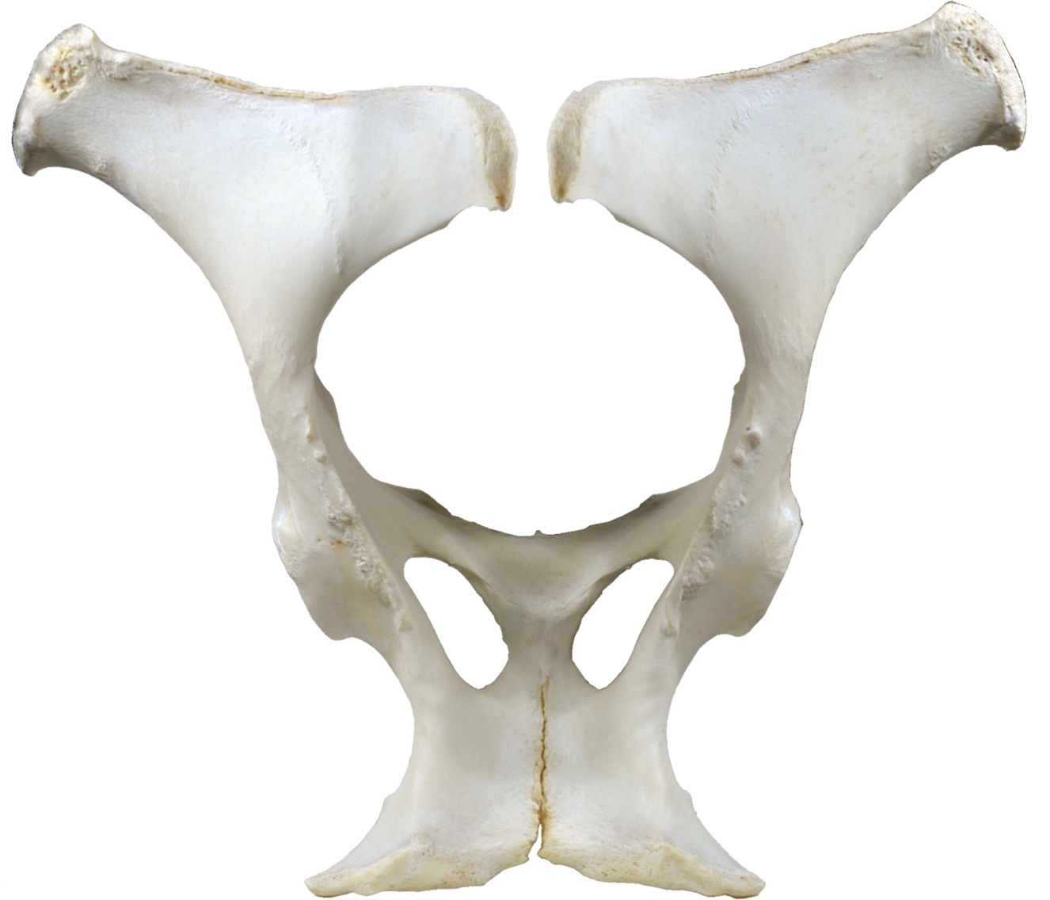  Comminuted
 | Complete |  | Incomplete
 | Displaced |  | Non-displaced
 | Articular |  | Non-articular

Location:
 | Proximal Epiphyseal |  | Distal Epiphyseal
 | Proximal Metaphyseal |  | Distal Metaphyseal
 | Proximal Physeal |  | Distal Physeal
 | Diaphyseal

Configuration:
 | Axial (longitudinal) |  | Butterfly
 | Transverse |  | Oblique
 | Segmental

Direction:
 | Proximodorsal-Distopalmar |  | Proximopalmar-Distodorsal
 | Proximolateral-Distomedial |  | Proximomedial-Distolateral
 | Sagittal |  | Dorsal plane (mediolateral)

Pre-existing callus:
 | Yes |  | No
 | Unable to evaluate
Legend:
Callus
Incomplete Fx;
M Missing fragments
Acc # Pelvis, Ventral
Date
CC

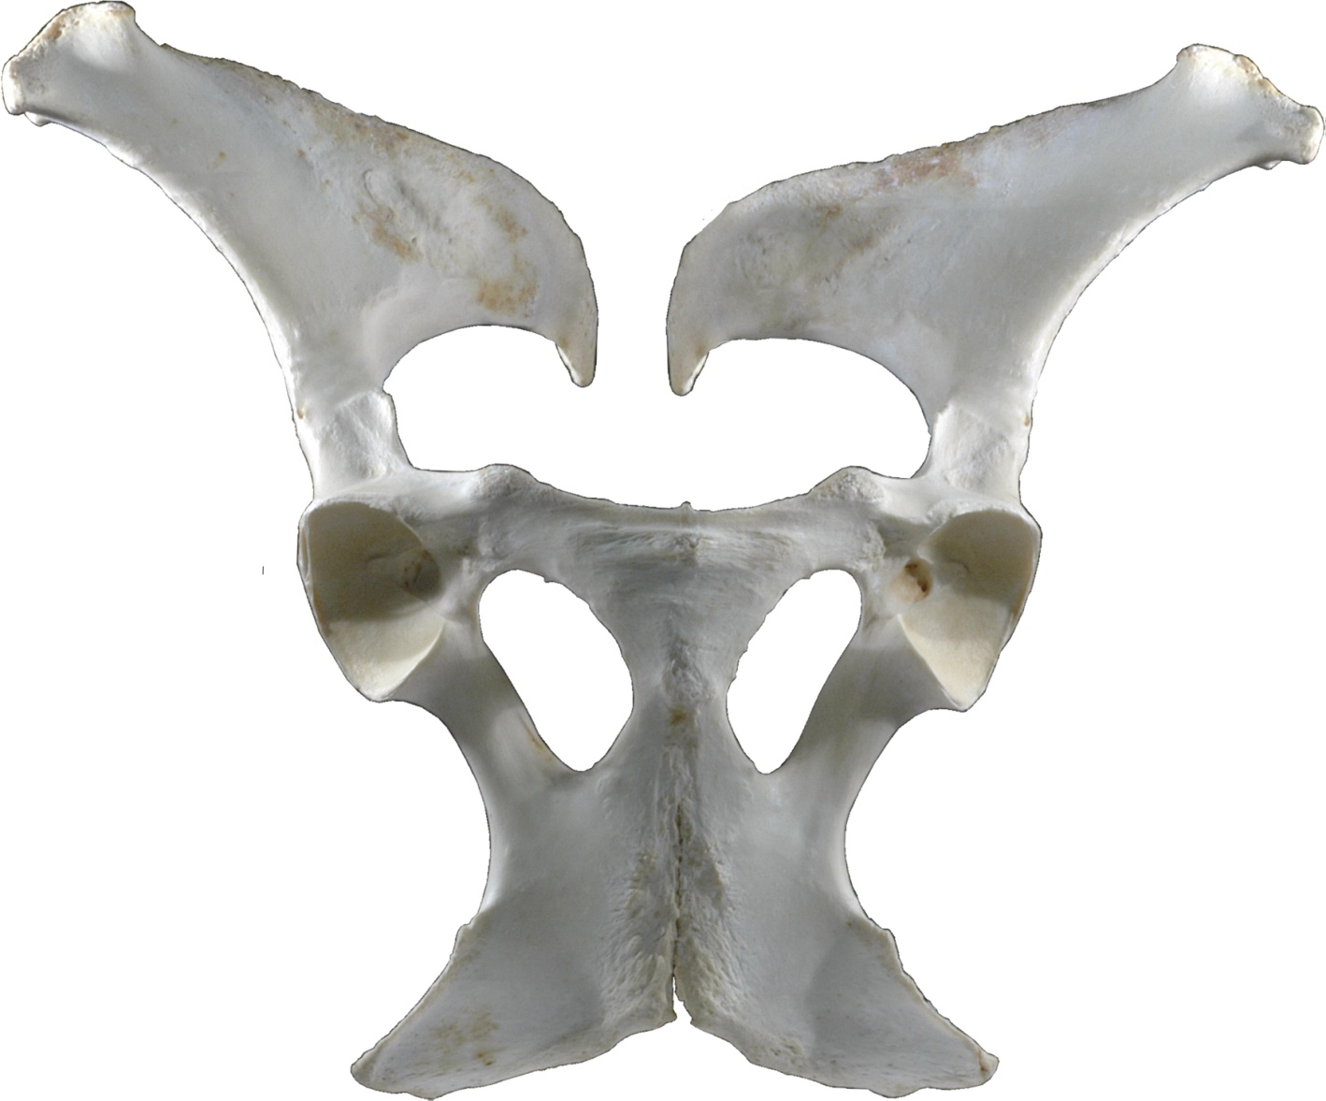
Nature:
 | Open |  | Closed
 | Simple |  | Comminuted
 | Complete |  | Incomplete
 | Displaced |  | Non-displaced
 | Articular |  | Non-articular

Location:
 | Proximal Epiphyseal |  | Distal Epiphyseal
 | Proximal Metaphyseal |  | Distal Metaphyseal
 | Proximal Physeal |  | Distal Physeal
 | Diaphyseal

Configuration:
 | Axial (longitudinal) |  | Butterfly
 | Transverse |  | Oblique
 | Segmental

Direction:
 | Proximodorsal-Distopalmar |  | Proximopalmar-Distodorsal
 | Proximolateral-Distomedial |  | Proximomedial-Distolateral
 | Sagittal |  | Dorsal plane (mediolateral)

Pre-existing callus:
 | Yes |  | No
 | Unable to evaluate
Legend:
Callus
Incomplete Fx;
M Missing fragments
Acc # Pelvis, Lateral - Left
Date
CC

Nature:
 | Open |  | 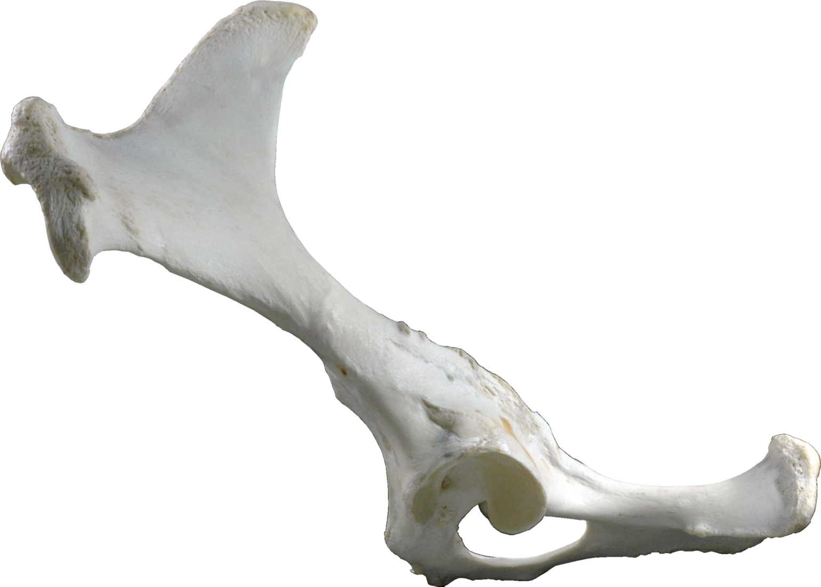  Closed
 | Simple |  | Comminuted
 | Complete |  | Incomplete
 | Displaced |  | Non-displaced
 | Articular |  | Non-articular

Location:
 | Proximal Epiphyseal |  | Distal Epiphyseal
 | Proximal Metaphyseal |  | Distal Metaphyseal
 | Proximal Physeal |  | Distal Physeal
 | Diaphyseal

Configuration:
 | Axial (longitudinal) |  | Butterfly
 | Transverse |  | Oblique
 | Segmental

Direction:
 | Proximodorsal-Distopalmar |  | Proximopalmar-Distodorsal
 | Proximolateral-Distomedial |  | Proximomedial-Distolateral
 | Sagittal |  | Dorsal plane (mediolateral)

Pre-existing callus:
 | Yes |  | No
 | Unable to evaluate
Legend:
Callus
Incomplete Fx;
M Missing fragments
Acc # Pelvis, Lateral - Right
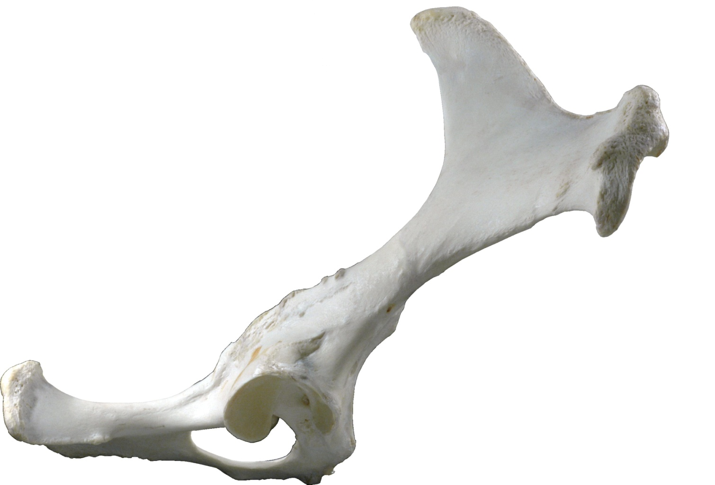
Date
CC

Nature:
 | Open |  | Closed
 | Simple |  | Comminuted
 | Complete |  | Incomplete
 | Displaced |  | Non-displaced
 | Articular |  | Non-articular

Location:
 | Proximal Epiphyseal |  | Distal Epiphyseal
 | Proximal Metaphyseal |  | Distal Metaphyseal
 | Proximal Physeal |  | Distal Physeal
 | Diaphyseal

Configuration:
 | Axial (longitudinal) |  | Butterfly
 | Transverse |  | Oblique
 | Segmental

Direction:
 | Proximodorsal-Distopalmar |  | Proximopalmar-Distodorsal
 | Proximolateral-Distomedial |  | Proximomedial-Distolateral
 | Sagittal |  | Dorsal plane (mediolateral)

Pre-existing callus:
 | Yes |  | No
 | Unable to evaluate
Legend:
Callus
Incomplete Fx;
M Missing fragments
Acc # Pelvis, Caudal
Date
CC

Nature:
 | Open |  | Closed
 | Simple |  | 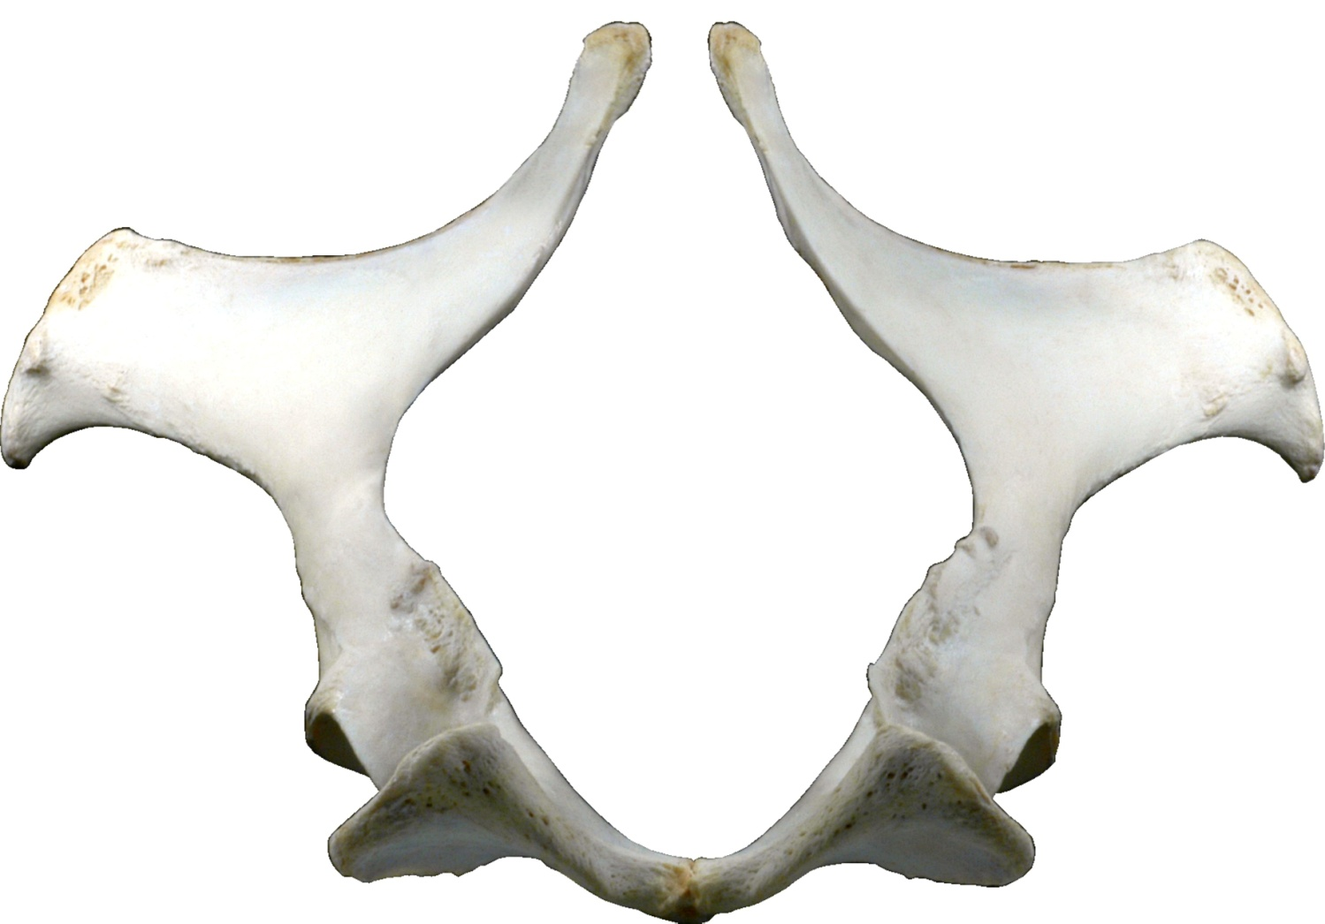  Comminuted
 | Complete |  | Incomplete
 | Displaced |  | Non-displaced
 | Articular |  | Non-articular

Location:
 | Proximal Epiphyseal |  | Distal Epiphyseal
 | Proximal Metaphyseal |  | Distal Metaphyseal
 | Proximal Physeal |  | Distal Physeal
 | Diaphyseal

Configuration:
 | Axial (longitudinal) |  | Butterfly
 | Transverse |  | Oblique
 | Segmental

Direction:
 | Proximodorsal-Distopalmar |  | Proximopalmar-Distodorsal
 | Proximolateral-Distomedial |  | Proximomedial-Distolateral
 | Sagittal |  | Dorsal plane (mediolateral)

Pre-existing callus:
 | Yes |  | No
 | Unable to evaluate
Legend:
Callus
Incomplete Fx;
M Missing fragments
Acc # Femur - Left
Date
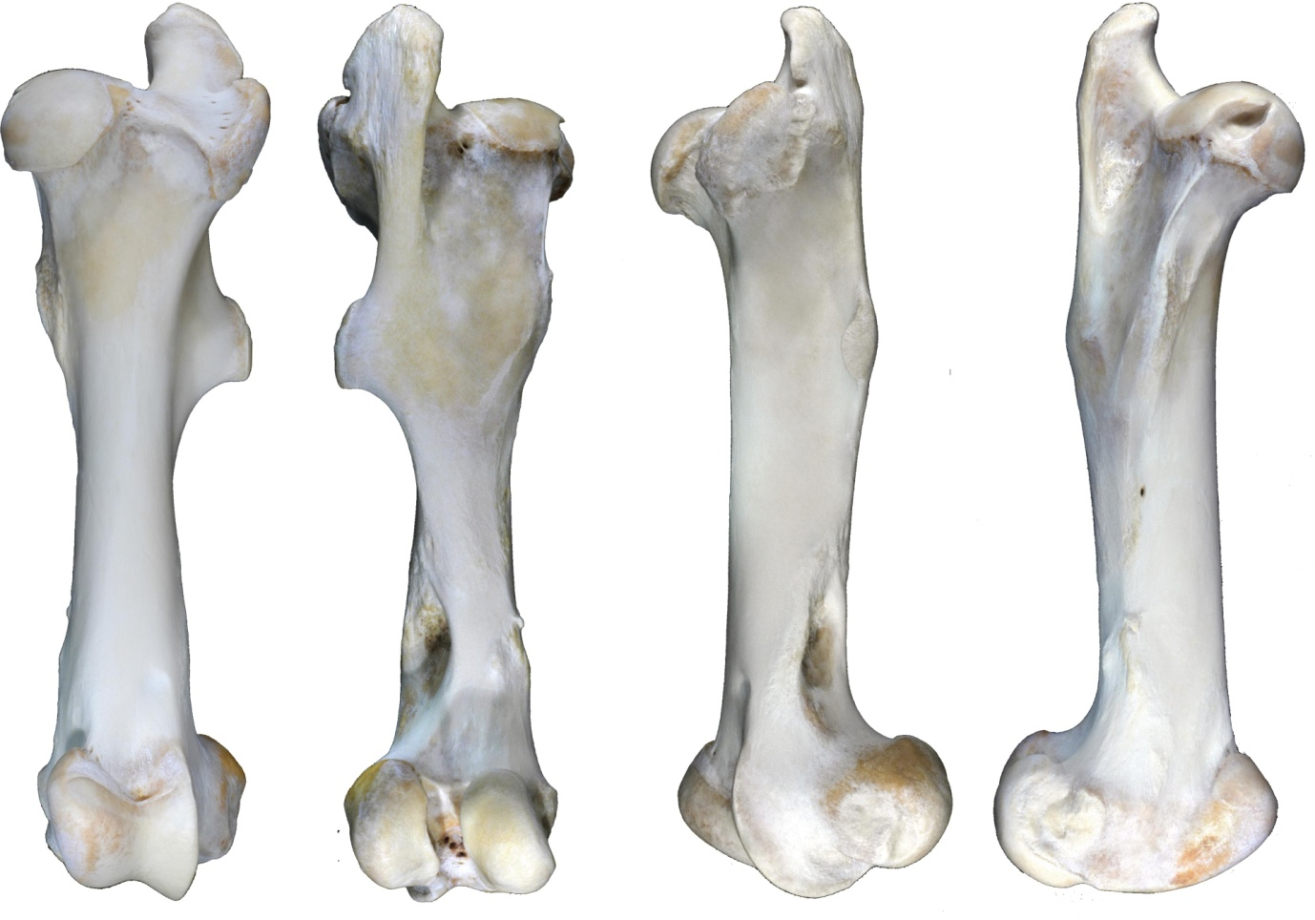
CC

Nature:
 | Open |  | Closed
 | Simple |  | Comminuted
 | Complete |  | Incomplete
 | Displaced |  | Non-displaced
 | Articular |  | Non-articular

Location:
 | Proximal Epiphyseal |  | Distal Epiphyseal
 | Proximal Metaphyseal |  | Distal Metaphyseal
 | Proximal Physeal |  | Distal Physeal
 | Diaphyseal
Configuration:
 | Axial (longitudinal) |  | Butterfly
 | Transverse |  | Oblique
 | Segmental

Direction:
 | Proximodorsal-Distopalmar |  | 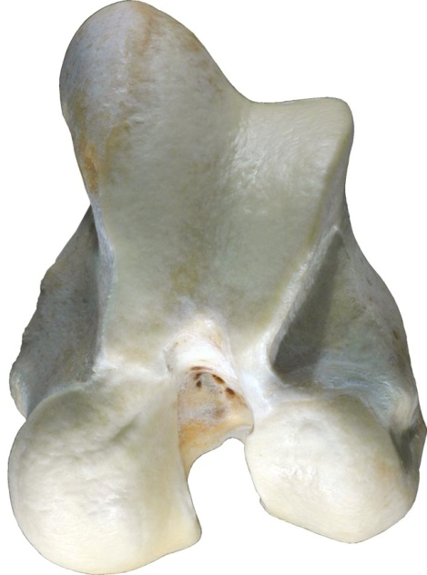  Proximopalmar-Distodorsal
 | Proximolateral-Distomedial |  | Proximomedial-Distolateral
 | Sagittal |  | Dorsal plane (mediolateral)
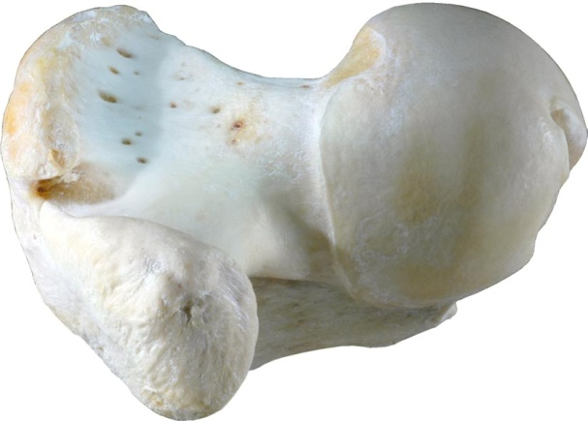
Pre-existing callus:
 | Yes |  | No
 | Unable to evaluate
Legend:
Callus
Incomplete Fx;
M Missing fragments
Acc # Femur - Right
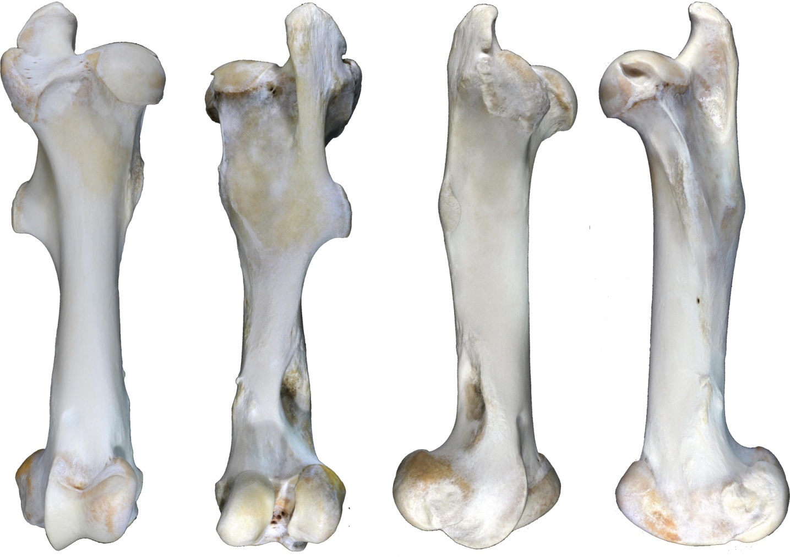
Date
CC

Nature:
 | Open |  | Closed
 | Simple |  | Comminuted
 | Complete |  | Incomplete
 | Displaced |  | Non-displaced
 | Articular |  | Non-articular

Location:
 | Proximal Epiphyseal |  | Distal Epiphyseal
 | Proximal Metaphyseal |  | Distal Metaphyseal
 | Proximal Physeal |  | Distal Physeal
 | Diaphyseal
Configuration:
 | Axial (longitudinal) |  | Butterfly
 | Transverse |  | Oblique
 | Segmental

Direction:
 | Proximodorsal-Distopalmar |  | 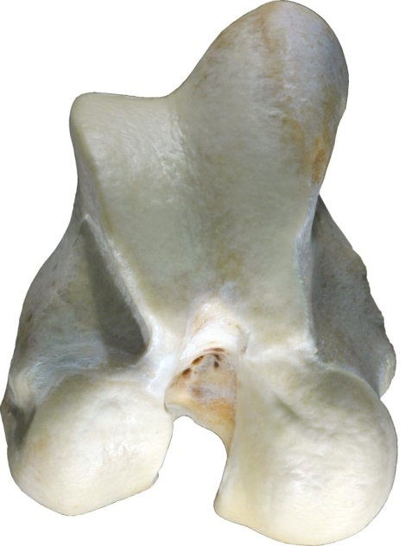  Proximopalmar-Distodorsal
 | Proximolateral-Distomedial |  | Proximomedial-Distolateral
 | Sagittal |  | Dorsal plane (mediolateral)
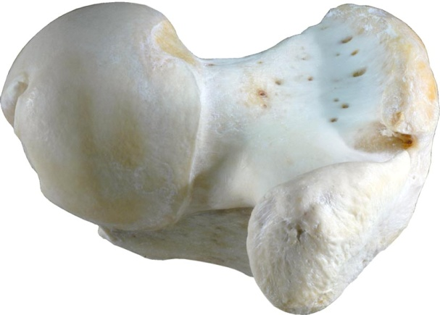
Pre-existing callus:
 | Yes |  | No
 | Unable to evaluate
Legend:
Callus
Incomplete Fx;
M Missing fragments
Acc # Stifle, Lateral - Left
Date
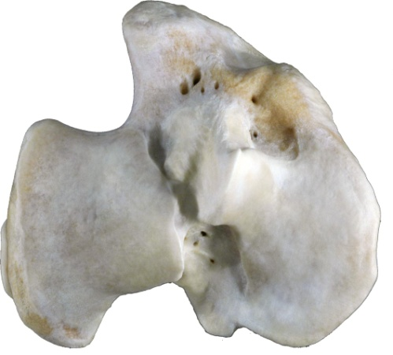
CC
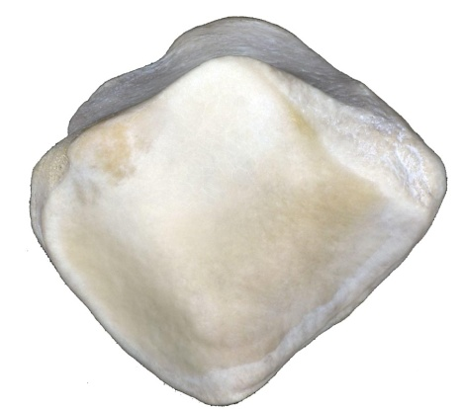
Nature:
 | Open |  | Closed
 | Simple |  | Comminuted
 | Complete |  | Incomplete
 | Displaced |  | Non-displaced
 | Articular |  | Non-articular

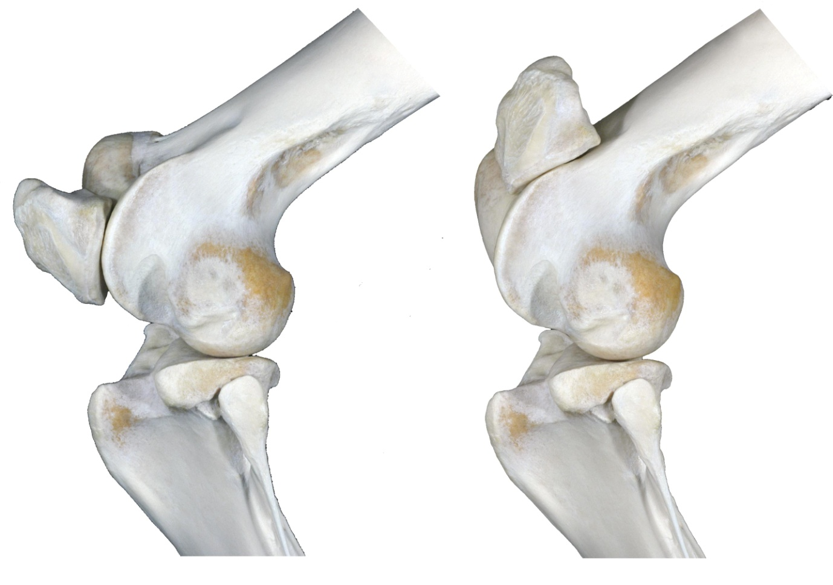
Location:
 | Proximal Epiphyseal |  | Distal Epiphyseal
 | Proximal Metaphyseal |  | Distal Metaphyseal
 | Proximal Physeal |  | Distal Physeal
 | Diaphyseal

Configuration:
 | Axial (longitudinal) |  | Butterfly
 | Transverse |  | Oblique
 | Segmental

Direction:
 | Proximodorsal-Distopalmar |  | Proximopalmar-Distodorsal
 | Proximolateral-Distomedial |  | Proximomedial-Distolateral
 | Sagittal |  | Dorsal plane (mediolateral)

Pre-existing callus:
 | Yes |  | No
 | Unable to evaluate
Legend:
Callus
Incomplete Fx;
M Missing fragments
Acc # Stifle, Lateral - Right
Date
CC

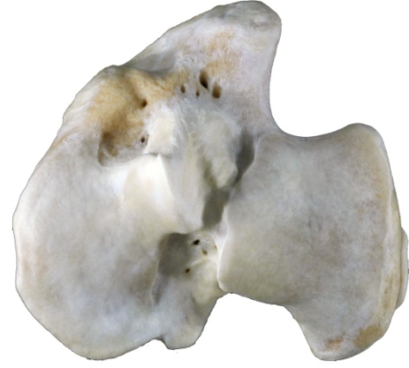
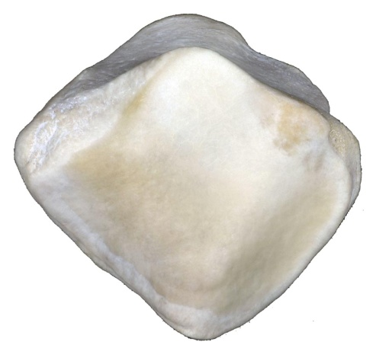
Nature:
 | Open |  | Closed
 | Simple |  | Comminuted
 | Complete |  | Incomplete
 | Displaced |  | Non-displaced
 | Articular |  | Non-articular

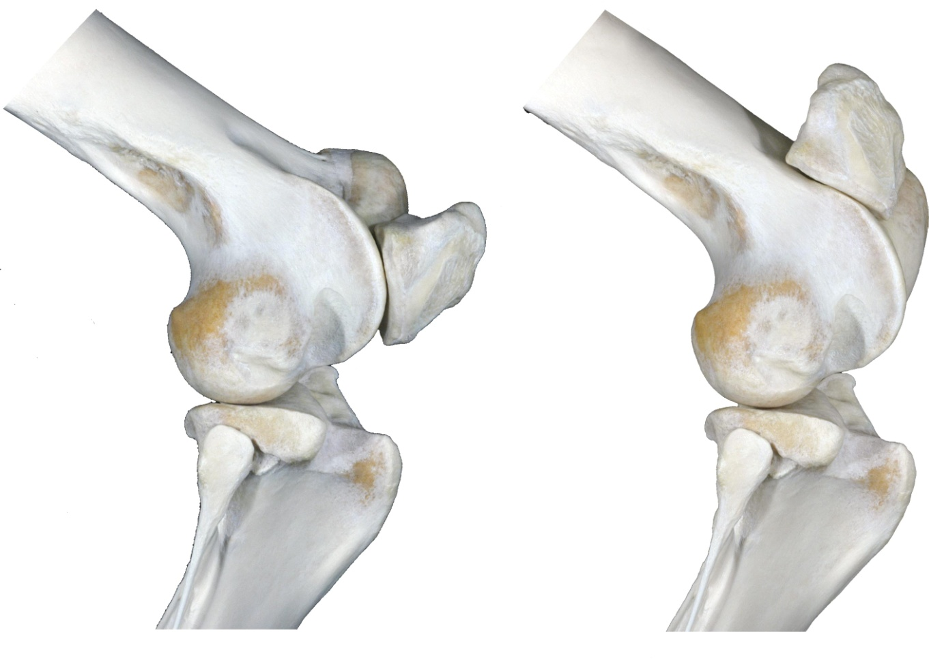
Location:
 | Proximal Epiphyseal |  | Distal Epiphyseal
 | Proximal Metaphyseal |  | Distal Metaphyseal
 | Proximal Physeal |  | Distal Physeal
 | Diaphyseal

Configuration:
 | Axial (longitudinal) |  | Butterfly
 | Transverse |  | Oblique
 | Segmental

Direction:
 | Proximodorsal-Distopalmar |  | Proximopalmar-Distodorsal
 | Proximolateral-Distomedial |  | Proximomedial-Distolateral
 | Sagittal |  | Dorsal plane (mediolateral)

Pre-existing callus:
 | Yes |  | No
 | Unable to evaluate
Legend:
Callus
Incomplete Fx;
M Missing fragments
Acc # Tibia - Left
Date
CC

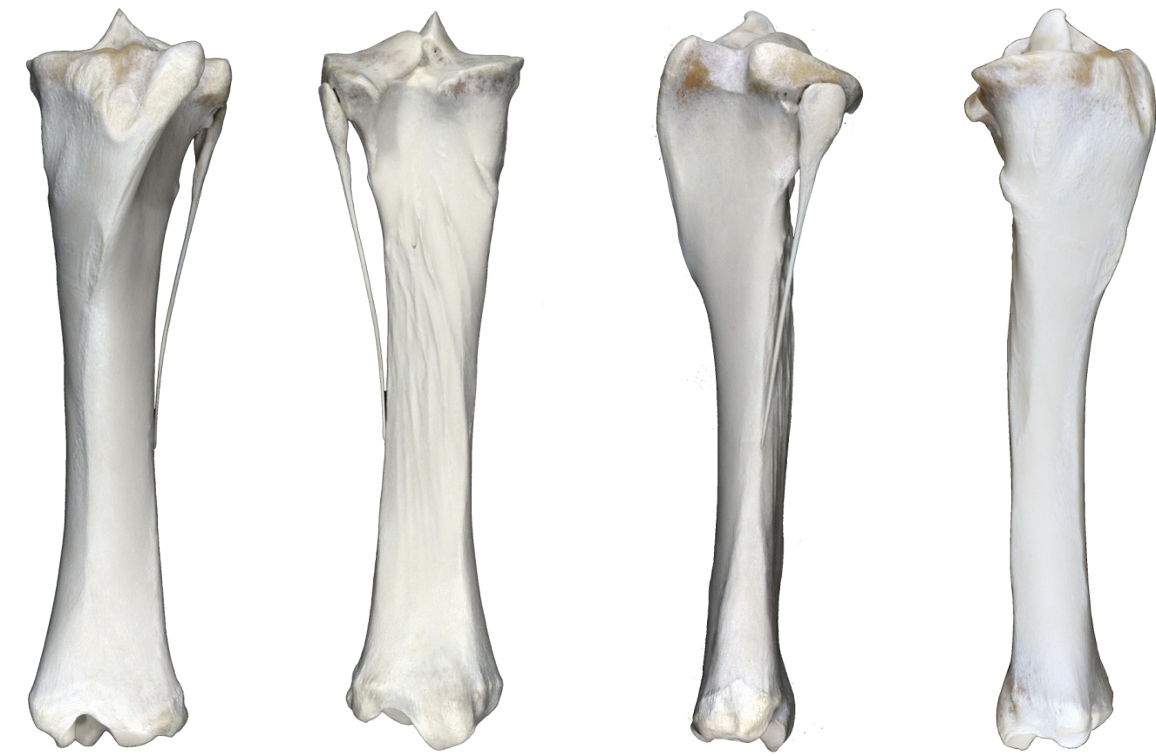
Nature:
 | Open |  | Closed
 | Simple |  | Comminuted
 | Complete |  | Incomplete
 | Displaced |  | Non-displaced
 | Articular |  | Non-articular

Location:
 | Proximal Epiphyseal |  | Distal Epiphyseal
 | Proximal Metaphyseal |  | Distal Metaphyseal
 | Proximal Physeal |  | Distal Physeal
 | Diaphyseal

Configuration:
 | Axial (longitudinal) |  | Butterfly
 | Transverse |  | Oblique
 | Segmental

Direction:
 | Proximodorsal-Distopalmar |  | Proximopalmar-Distodorsal
 | Proximolateral-Distomedial |  | 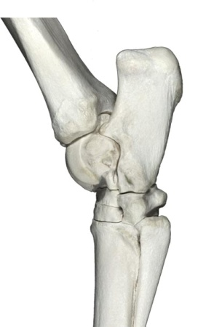  Proximomedial-Distolateral
 | Sagittal |  | 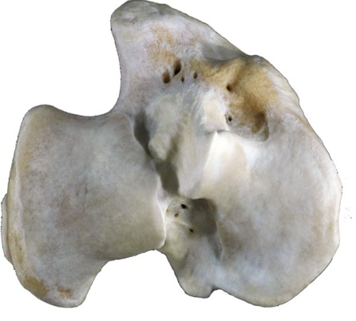  Dorsal plane (mediolateral)

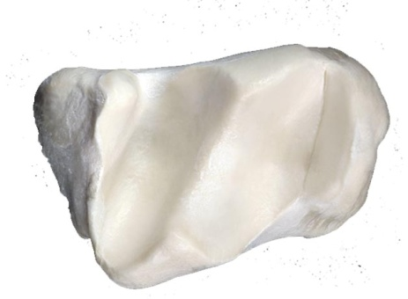
Pre-existing callus:
 | Yes |  | No
 | Unable to evaluate
Legend:
Callus
Incomplete Fx;
M Missing fragments
Acc # Tibia - Right
Date
CC

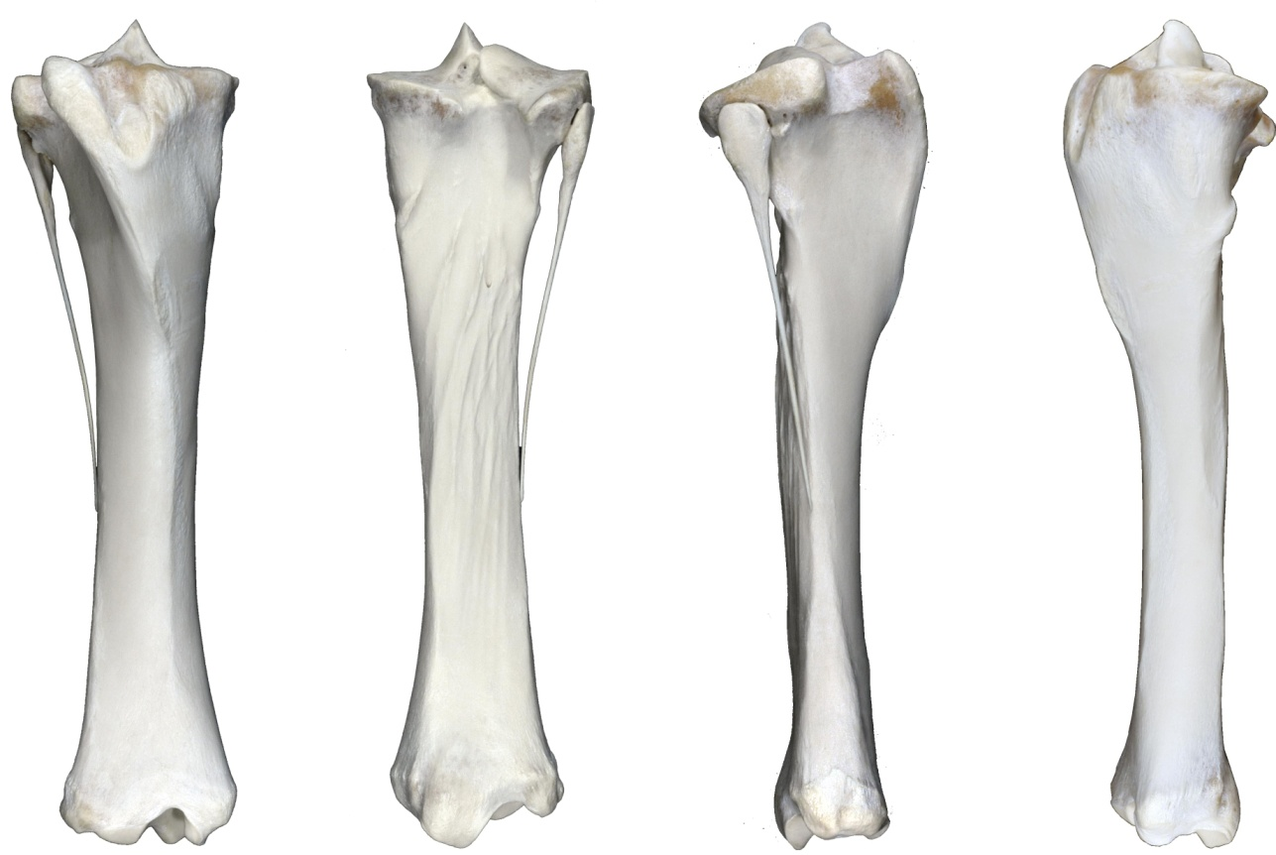
Nature:
 | Open |  | Closed
 | Simple |  | Comminuted
 | Complete |  | Incomplete
 | Displaced |  | Non-displaced
 | Articular |  | Non-articular

Location:
 | Proximal Epiphyseal |  | Distal Epiphyseal
 | Proximal Metaphyseal |  | Distal Metaphyseal
 | Proximal Physeal |  | Distal Physeal
 | Diaphyseal

Configuration:
 | Axial (longitudinal) |  | Butterfly
 | Transverse |  | Oblique
 | Segmental

Direction:
 | Proximodorsal-Distopalmar |  | Proximopalmar-Distodorsal
 | Proximolateral-Distomedial |  | Proximomedial-Distolateral
 | Sagittal |  | 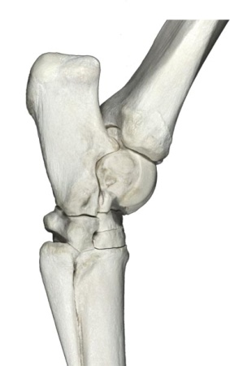  Dorsal plane (mediolateral)

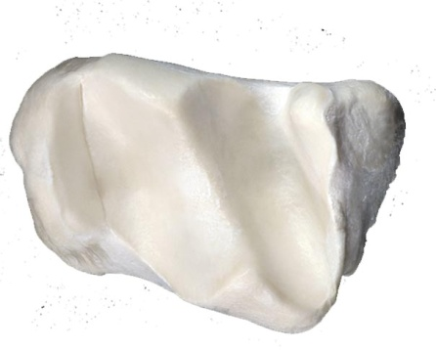
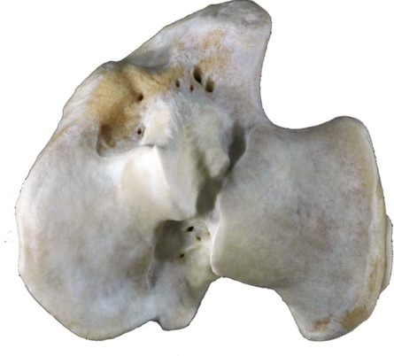
Pre-existing callus:
 | Yes |  | No
 | Unable to evaluate
Legend:
Callus
Incomplete Fx;
M Missing fragments
Acc # Fetlock - Left
Date
CC
 | Collateral Ligs |  | yes |  | no
 | Suspensory Lig
 | Body |  | yes |  | no
 | Medial Br |  | yes |  | no
 | Lateral Br |  | yes |  | no
 | Intersesamoidean Lig
 | Longitudinal |  | yes |  | no
 | Transverse |  | yes |  | no
 | Distal Sesamoidean Ligs
 | Straight |  | yes |  | no
 | Oblique |  | yes |  | no
 | Condyle
 | Medial ____ cm |  | yes |  | no
 | Lateral ____ cm |  | yes |  | no
Involved Structures:

Subchondral lesión:
 | Yes |  | No
 | Unable to evaluate

 | Yes |  | No
 | Unable to evaluate
Pre-existing callus:

Callus
Incomplete Fx
M Missing fragments

Acc # Fetlock - Right
Date
CC

 | Collateral Ligs |  | yes |  | no
 | Suspensory Lig
 | Body |  | yes |  | no
 | Medial Br |  | yes |  | no
 | Lateral Br |  | yes |  | no
 | Intersesamoidean Lig
 | Longitudinal |  | yes |  | no
 | Transverse |  | yes |  | no
 | Distal Sesamoidean Ligs
 | Straight |  | yes |  | no
 | Oblique |  | yes |  | no
 | Condyle
 | Medial ____ cm |  | yes |  | no
 | Lateral ____ cm |  | yes |  | no
Involved Structures:
Subchondral lesión:
 | Yes |  | No
 | Unable to evaluate

Pre-existing callus:
 | Yes |  | No
 | Unable to evaluate

Callus
Incomplete Fx;
M Missing fragment

